**HANGING ROCK**

**STRATEGIC PLAN**

Acknowledgements

The following groups contributed to the preparation of the Plan:

* Traditional Owners :
  + The Dja Dja Wurrung Clans Aboriginal Corporation
  + The Taungurung Clans Aboriginal Corporation
  + The Wurundjeri Tribe Land and Compensation Cultural Heritage Council
* Hanging Rock Strategic Advisory Committee

Consultant Team

* Ethos Urban Pty Ltd (Project Management, Planning, Landscape Assessment)
* Extent Heritage (Cultural Heritage)

*Accessibility*

*If you would like to receive this publication in an alternative format, please telephone the DELWP Customer Service Centre on 136186, email* [*customer.service@delwp.vic.gov.au,*](mailto:customer.service@delwp.vic.gov.au) *or via the National Relay Service on 133 677* [*www.relayservice.com.au.*](http://www.relayservice.com.au/) *This document is also available on the internet at* [*www.delwp.vic.gov.au.*](http://www.delwp.vic.gov.au/)

*© The State of Victoria Department of Environment, Land, Water and Planning 2018*



*This work is licensed under a Creative Commons Attribution 4.0 International licence. You are free to re-use the work under that licence, on the condition that you credit the State of Victoria as author. The licence does not apply to any images, photographs or branding, including the Victorian Coat of Arms, the Victorian Government logo and the Department of Environment, Land, Water and Planning (DELWP) logo. To view a copy of this licence, visit* [*http://creativecommons.org/licenses/by/4.0/*](http://creativecommons.org/licenses/by/4.0/)

*ISBN 978-1-76077-310-6 (print)*

*Disclaimer*

*This publication may be of assistance to you but the State of Victoria and its employees do not guarantee that the publication is with- out flaw of any kind or is wholly appropriate for your particular purposes and therefore disclaims all liability for any error, loss or other consequence which may arise from you relying on any information in this publication.*

Foreword

Hanging Rock’s living history represents a unique culture of gathering, exchange, reflection and intrigue. We pay our respects to the Traditional Owners of this land who have cared for and nurtured this place for thousands of years.

The melting pot of magnificent geological formations, stunning biodiversity and human recreational pursuits brings many admirers to this place - a privilege we want future generations to be able to enjoy.

Hanging Rock’s cultural, social and heritage significance is why the state government is committed to protecting the unique mix of environmental and cultural values. A crucial element in the protection of Hanging Rock is to celebrate, support and re-establish the culture connection of the Aboriginal peoples with this land.

We are proud that the Hanging Rock Strategic Plan will set the direction to protecting the cultural and environmental values of Hanging Rock. This accomplishment was achieved with the support, pride and conviction of the local custodians who participated in extensive consultation over the past three years.

The Victorian Government thanks the local community, the Hanging Rock Strategic Advisory Committee, Macedon Ranges Shire Council and the Traditional Owners for their valuable contributions. We now have a shared vision on how to protect the values that make Hanging Rock such an iconic place and how the site will be sustainably protected and enjoyed into the future.

###### An image of the signature of the Hon. Richard Wynne MP, Minister for Planning. An image of the signature of the Hon. Lily D'Ambrosio MP, Minister for Energy, Environment and Climate Change, and Minister for Suburban Development.

The Hon. Richard Wynne MP Minister for Planning

The Hon. Lily D’Ambrosio MP Minister for Energy, Environment and Climate Change

Minister for Suburban Development

Foreword

Hanging Rock is a distinctive and dominant feature of the landscape of the Macedon Ranges, and one of the most well loved places to visit in the shire. It is renowned for its unique geology, landscapes, diverse flora and fauna, significant Aboriginal history and its post-contact heritage.

For many thousands of years it was a site where Aboriginal peoples gathered. Its more recent history includes the tales of bushrangers, horse racing, concerts and of course Joan Lindsey’s Picnic at Hanging Rock.

It remains today a gathering place for locals and visitors. Situated within the Cobaw biolink, it also provides sanctuary for rare and threatened native flora and fauna such as powerful owls, greater gliders and brush-tailed phascogales.

Now, we see the large boulders ‘hanging’, and go there for celebration and reflection. We need to protect everything that is unique about ‘the Rock’ and its surrounds for those who come after us.

This strategy has seen the State Government, Macedon Ranges Shire Council, Traditional Owners and the local community all involved in the stewardship of Hanging Rock. It will ensure that future decision-making embraces the Rock’s ancient history and allows us to build on these partnerships; securing conservation and an appreciation and respect deserving of the precinct by all who visit today and in the future.



Cr. Jennifer Anderson

Mayor for Macedon Ranges Shire Council

Contents Contents

Executive Summary **vi**

4.0 Values

4.1 Values 60

4.1.1 Aboriginal Traditional Owners **61**

###### 1.0 Hanging Rock Strategic Plan

1.1 Hanging Rock Strategic Plan **2**

|  |  |  |
| --- | --- | --- |
| 1.1.1 | The Precinct | **2** |
| 1.1.2 | The Wider Study Area | **2** |

###### 2.0 History of Hanging Rock

|  |  |  |  |  |  |
| --- | --- | --- | --- | --- | --- |
|  | | | 4.1.8 | Macedon Ranges Shire Council | **70** |
| 2.1 | Timeline Summary | **8** | 4.1.9 | The wider community of Victoria | **71** |
| 2.2 | At the beginning... | **10** | 4.2 | Issues and Opportunities | **72** |
| 2.3 | Aboriginal Traditional Owners | **11** | 4.2.1 | Common Values | **72** |
| 2.4 | White Colonisation | **14** | 4.2.2 | Conflicts/ Issues | **73** |

* + 1. Post-Contact Heritage **64**
    2. Environmental Interest Groups **66**
    3. Local Groups and Residents **67**
    4. Event Attendees **68**
    5. Visitors **69**
    6. Local businesses **70**
  1. The Mystery **16**
  2. Recent History **17**

###### 

3.0 Geology & Environment

* 1. Geological Setting **20**
  2. Landscape Setting **22**
  3. Ecological Setting **24**

4.2.3 Opportunities **75**

|  |  |  |
| --- | --- | --- |
| 5.0 | Vision & Objectives |  |
| 5.1 | The Vision | **78** |
| 5.2 | Objectives | **79** |
| 5.3 | Strategies | **80** |

* + 1. Governance and Management **80**
    2. Environment **80**

|  |  |  |  |  |  |
| --- | --- | --- | --- | --- | --- |
| 3.3.1 | Bioregions and Ecology | **24** |  | | |
| 3.3.2 | Flora | **28** | 5.3.3 | Culture and Heritage | **81** |
| 3.3.3 | Fauna | **35** | 5.3.4 | Tourism and Recreation | **82** |
| 3.3.4 | Waterways | **38** |  |  |  |
| 3.4 | Visual Setting | **40** | 6.0 | Governance |  |
| 3.4.1 | Overview of Visual Character | **40** | 6.1 | Governance Options | **86** |
| 3.4.2 | Types of Views | **41** | 6.1.1 | Committee of Management | **86** |
| 3.4.3 | Culturally Important Views | **41** | 6.2 | Funding Opportunities | **88** |
| 3.4.4 | Key Views | **45** |  |  |  |
|  |  |  | 7.0 | Implementation |  |
|  |  |  | 8.0 | References |  |
|  |  |  | 9.0 | Appendicies |  |

Figures

Figure 1. Hanging Rock Precinct Map **3**

Figure 2. Regional Context of Hanging Rock **4**

Figure 3. Vicinity of Hanging Rock Precinct **5**

Figure 4. Topographical Setting of Hanging Rock **21**

Figure 5. Bioregional Setting of Hanging Rock **25**

Figure 6. Cobaw Biolink **27**

Figure 7. Ecological Vegetation Classes pre-1750 **30**

Figure 8. Ecological Vegetation Classes in 2005 **31**

Figure 9. Ecological Vegetation Classes pre-1750 at Hanging Rock Precinct **32**

Figure 10. Ecological Vegetation Classes in 2005 at Hanging Rock Precinct ( DELWP Mapping) **33**

Figure 11. Recommended Ecological Vegetation Classes 2015 at Hanging Rock Precinct (Environmental Management Plan) **34**

Figure 12. Threatened Fauna Species **36**

Figure 13. Culturally Important Views & Visual Connections **42**

Figure 14. Significant Views **43**

Figure 15. Significant Views: Hanging Rock Precinct **44**

Figure 16. Existing Activities in Hanging Rock Precinct **61**

Figure 17. Entrance Revenues at Hanging Rock. Source: SGS Economics & Planning (2018) **62**

Figure 18. Strategic Plan for Hanging Rock Precinct **102**

Appendix

Appendix 1 Locally Significant Views **c**

Appendix 2 Existing Activities in Hanging Rock Precinct **civ**

### Executive Summary

##### Hanging Rock Strategic Plan

Hanging Rock is an iconic and highly significant feature of the Victorian and Australian landscape. It has a multitude of meanings and values

to people and groups who interact with the Rock and its precinct. This Strategic Plan attempts to address and identify these values and their implications for determining the objectives for the future of the Rock.

In 2016, the Victorian State Government reconfirmed the responsibility of the management of the reserve to the Council. As part of this agreement, a new masterplan for the precinct will be developed between DELWP

and the Macedon Ranges Shire Council. By examining the range of values held about the place, we can determine the objectives that will drive development of the more detailed Plan. The Strategic Plan provides a vision for the future uses of the Rock and its immediate surrounds for the next 50 years. It also:

* + - * Provides objectives, strategies and actions to support implementation of the Vision
      * Provides a management plan to inform a governance model
      * Identifies action priorities and timeframes

*Throughout this document the Traditional Owners’ names ‘Wurundjeri’, ‘Dja Dja Wurrung’ and ‘Taungurung’ are alternated to reflect the current status in Right People for Country boundary negotiations where each party is negotiating on an equal basis. Each of the three Traditional Owner groups asserts traditional ownership of the country that includes the Hanging Rock Precinct

##### History of Hanging Rock

The birth of the rock formation popularly known today as Hanging Rock, occurred over six million years ago. A volcanic eruption of stiff magma created what is now one of the most easily accessible and visible mamelon forms in the world.

Hanging Rock is located near the traditional boundary between three Aboriginal tribal groups – the Woi Wurrung (Wurundjeri), the Dja Dja Wurrung and the Taungurung*. Archaeological evidence found at Hanging Rock demonstrates Aboriginal use and occupation of the place for at least 10,000 years. As a prominent, culturally significant landmark near tribal boundaries with a reliable source of water, the rock is likely to have been used for Ngargee ceremonies (Corroborrees) and other traditional business that involved gatherings.

Originally surveyed in 1843 by Robert Hoddle and named Diogenes Mount.

The first map was made in 1844. In 1857, the lot containing the majority of the Hanging Rock was purchased and in the 1860s it was developed for a ‘pleasure resort’. The Hanging Rock once again became a popular site for gatherings, this time for picnics. The Hanging Rock Racing Club

was formed in 1885, conducting biannual races which continue to this day. Several local sporting facilities have been located in the Precinct more recently.

In recent decades, Hanging Rock has been widely popular for its mystery and stories, in part thanks to the international success of the book and film Picnic at Hanging Rock in 1975.

Recent music concerts have been held since the 2010s, often featuring well known overseas acts. Since the 1970s upgrades to facilities, paths, tracks, toilets and additional picnic shelters has ensured that the reserve continues to be a popular place for visitors to gather and picnic.

##### Geology & Environment

Geological Setting

Hanging Rock is located within an area of the Great Dividing Range, a system of elevated areas such as Mount Macedon and the Kinglake Plateau further east that are comprised of rock deposited in massive volcanic eruptions around 36-370 million years ago.

Hanging Rock itself is of different geological origins, being a rock formation known as a mamelon created by the eruption of thick lava through a narrow vent in the bedrock below resulting in a steep-sided, volcanic structure. Geologically dated back to around 6.25 million years ago, subsequent weathering of the radial cooling joints have formed the distinctive outcrops of rock.

The geology of Hanging Rock is of National Significance as it illustrates the influence of lava composition on volcano form and is the best example of this geological formation in Victoria.

Landscape Setting

Hanging Rock is a unique feature that retains a noble presence within the visually dominant context of the MacedonRanges. As a landscape setting, the Macedon Ranges including the Hanging Rock area is of state significance, with exceptional landscape features, edges and contrast, and compositional values. The Macedon Ranges has increasingly become under pressure for growth and change due to its high aesthetic values, accessibility and its proximity to Melbourne. However, the region plays an important role in the state for tourism, agribusiness and lifestyle, linked strongly to Melbourne. The key values, attributes and activities of the region require recognition and protection to ensure they can continue to be accessible and enjoyed well into the future.

Ecological Setting

The Macedon Ranges region is located within the Central Victorian Uplands bioregion and the Victorian Volcanic Plains. The Hanging Rock Precinct is one of the few larger patches of remnant vegetation in the plains between Mount Macedon and the Cobaw Range. The Hanging Rock Precinct itself comprises a number of Ecological Vegetation Classes that are threatened to some extent within the Central Victorian Uplands.

The Precinct includes several flora species of regional significance and two rare / threatened flora species of state significance. 692 fauna species are recorded as occurring within 5km of the Precinct. Of these, five species are listed nationally under the EPBC Act, and 25 species are listed on the Victorian Advisory List.

Visual Setting

The significant views in the study area are generally divided between those which look over the rural landscape, focusing on land forms such as Hanging Rock (and Mount Macedon), or those looking outwards from locations within or on Hanging Rock. Within these, there are short and

long-range views, which reflect the variety of viewing distances which are visible from the viewing location.

Four State Significant views associated with Hanging Rock were identified, as well as five Regionally Significant views and seven Locally Significant views. Culturally significant views to the Aboriginal Traditional Owners have also been identified.

##### Existing Activities in Hanging Rock (see Appendix 2)

In addition to the day tripper activities, the reserve facilitates a horse racetrack with bi-annual races, summer markets, car shows and other one-off events. Concerts are held intermittently in the East Paddock in the warmer months. Local sporting clubs utilise facilities at the reserve including: tennis courts, a cricket oval and a petanque piste.

The variety of program of activities in Hanging Rock has contributed to its increase in popularity as a place to visit for local residents and tourists.

##### Values

Hanging Rock is highly valued for many different reasons, and different groups value different elements and aspects of the Rock and its environs. It is vital to understand the values held by all the different stakeholders in order to determine the future of the Hanging Rock precinct.

The different human user groups for Hanging Rock include:

* Aboriginal Traditional Owners
* Environmental Interest Groups (includes Flora and Fauna)
* Local Residents (including local sports clubs)
* Event Attendees
* Visitors
* Local Businesses
* Macedon Ranges Shire Council
* The wider Victorian community

In the preparation of this Strategic Plan, the three Aboriginal Traditional Owners have been consulted with and their identified cultural values used as an input into the Values assessment. The values of other groups

listed have been identified through broad consultation during the previous Hanging Rock investigation work, undertaken in 2016 by Aspect Studios and Village Well consultants.1

1 Aspect Studios (2018)

Many opportunities can be drawn from the common values and further expanded to inform a vision and supporting objectives for the Hanging Rock Strategic Plan.

Identified opportunities include:

* + Incorporating a new principle of ‘joint management’ with the Aboriginal Traditional Owners
  + Incorporating education into the experience of visiting Hanging Rock.
  + Improving the nature-based tourism potential of the reserve.
  + Investigation of improved visitor information facilities.
  + Revenue to support cafe and facility upgrades to enhance visitation and promote return trips.
  + Management of the actual Rock to guide walks, upgrade paths and limit access.
  + Guiding visitors to experience other walks at the base of the Rock and to viewing platforms around the reserve.
  + Improving biodiversity and environmental values on the Rock and the East Paddock.
  + Directing visitors to maximise picnic opportunities and views from the East Paddock.
  + Protection of prominent viewlines from Hanging Rock to Camel’s Hump.
* Cross promotion of Hanging Rock and the Macedon Ranges region for tourism opportunities.
* Long term possibilities of amalgamating and relocating sports clubs with other regional sports venues.
* Improved access arrangements.
* Establishment of ongoing funding sources.

##### Vision

The Vision for Hanging Rock for the next 50 years to 2068 is:

*“Hanging Rock will be renowned for its importance to our First Peoples, its dramatic geological form and its wider landscape setting within the Macedon Ranges. The role of the Rock throughout history as a place*

*of gathering, reflection and intrigue will be understood and celebrated. The revegetated bushland environment will enhance the secluded ambience and provide a habitat for native wildlife. Activities around the Rock will reflect its historical uses centred on recreation and education, and its State and national significance. ”*

##### Objectives

The following Objectives have been identified arising out of the common values and issues for consideration:

Governance and management objective

* Implement a detailed plan the ensures the long term development and management of Hanging Rock is sustainable

Environmental Objectives

* Improve and protect the environmental values of the Precinct
* Improve and protect the visual landscape values of the Precinct

Culture and Heritage Objectives

* Protect Traditional Owners’ heritage and cultural values
* Build visitor’s knowledge and awareness about the heritage of the place, and importance of the place to the Traditional Owners
* Recognise and preserve the significant Post-Contact heritage and historical associations with the Precinct
* Recognise and reflect the national and state role and significance of Hanging Rock in management and legislative arrangements

Tourism and Recreation Objectives

* Manage sporting and recreational activities to reflect the role and significance of the Precinct
* Support the continuing association of Hanging Rock as a place of gathering accessible to all visitors
* Foster the tourism role of the Precinct in the region and State

It is recommended that a revised management approach is required to recognise the ongoing connection of Traditional Owners to this important place for their culture.

This new governance structure is proposed to be a joint management approach, with a formal partnership arrangement between Aboriginal Traditional Owners and the relevant government land management body, whereby both share their knowledge to manage the Hanging Rock Precinct as partners.

Key principles have been identified by Aboriginal Traditional Owners that must be considered for Hanging Rock, and these have been included In the strategies outlined in this Strategic Plan and the Governance model recommendations.

A range of funding opportunities has been researched and further outlined in the report.

1.01.0

HANGING

ROCK

STRATEGIC

PLAN

### Hanging Rock Strategic Plan

###### Hanging Rock is an iconic and highly significant feature of the Victorian and Australian landscape. It has a multitude of meanings and values to people and groups who interact with the Rock and

its precinct. This Strategic Plan attempts to address and identify these values and their implications for determining the objectives for the future of the Rock.

In 2016, the Victorian State Government reconfirmed the responsibility of the management of the reserve to the Council. As part of this agreement, a new master plan for the precinct will be developed between DELWP

and the Macedon Ranges Shire Council. By examining the range of values held about the place, we can determine the objectives that will drive development of the more detailed Plan. The Strategic Plan provides a vision for the future uses of the Rock and its immediate surrounds for the next 50 years. It also:

* + Provides objectives, strategies and actions to support implementation of the Vision
  + Provides a management plan to inform a governance model
  + Identifies action priorities and time frames
    1. The Precinct

The Hanging Rock Precinct, as shown on the map at page 3, is bound by Colwells Road to the north, Straws Lane to the east, South Rock Road to the south and the cessation of Maxted Road and the rock itself to the west.

The two lots containing the Rock formation are Crown land that was gazetted in 1870 (the Reserve). The Hanging Rock reserve was permanently reserved for the purpose of ‘‘Public recreation and for

affording access to water’’ in the government gazette dated November

28, 1884. It is zoned Public Conservation and Resource Zone, which provides for the protection and conservation of the natural environment, natural processes and heritage, scientific, landscape, habitat or cultural significance.

The East Paddock, which contains the four lots to the east, was later purchased by the former Newham and Woodend Shire Council in 1993. This land is zoned Public Park and Recreation Zone, which recognises land for public recreation and open space.

For the purposes of the Hanging Rock Strategic Plan, the six lots form the study area (the Precinct) in terms of proposed activities, upgrades and management of Hanging Rock.

##### The Wider Study Area

A wider study area has been considered for the following:

* Immediate vicinity - land between Hanging Rock, Mount Macedon, Cobaw and Woodend; it is land that may impact or be impacted by views, water flows and other environmental links, land ownership and access or movement.
* Views - to and from the Rock, this includes as far as Mount Macedon and the Cobaw Ranges, as well as surrounding land.
* The Macedon Ranges - as a catchment area for activities, events, recreation and resident values, as well as its landscape and environmental setting.

At an even broader level Hanging Rock is assessed at a State and National level for its significance in terms of geology, landscape and traditional cultural values.

Figure 1. Hanging Rock Precinct Map (Existing Uses)

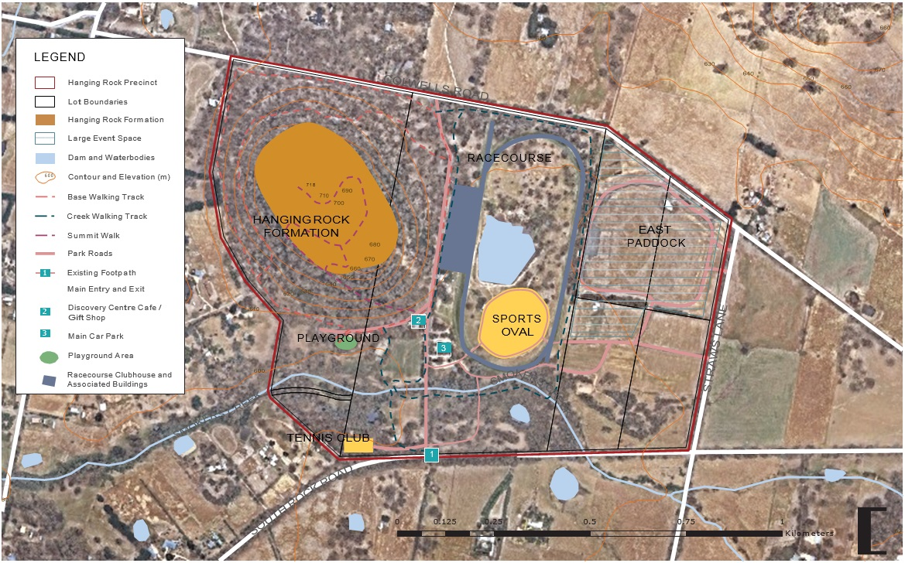

Figure 2. Regional Context of Hanging Rock

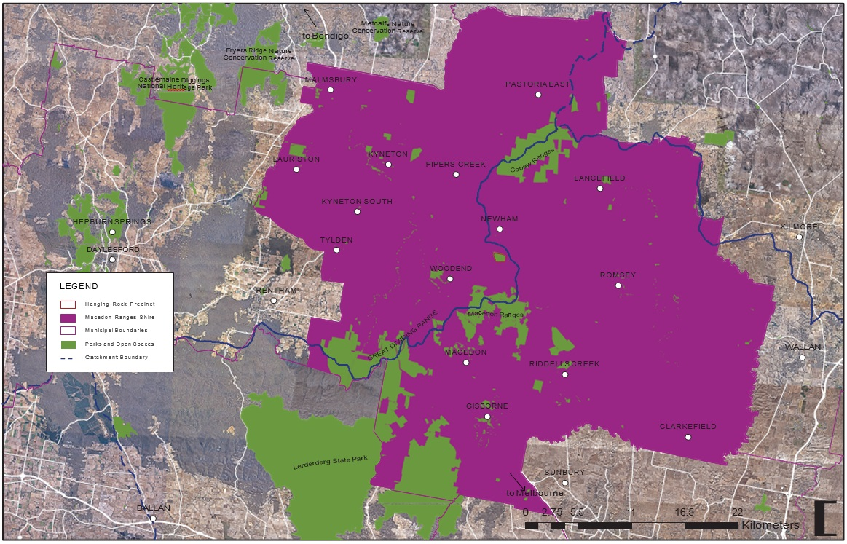

Figure 3. Vicinity of Hanging Rock Precinct

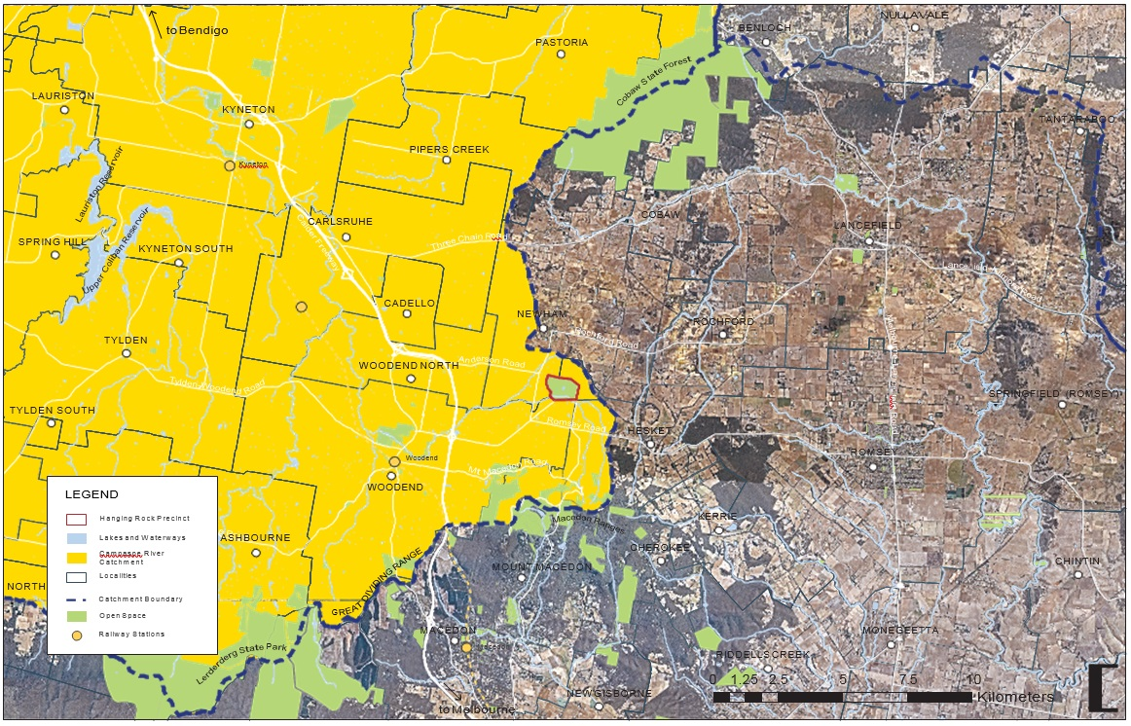

# 2. 3.0

HISTORY OF HANGING ROCK

### Timeline Summary

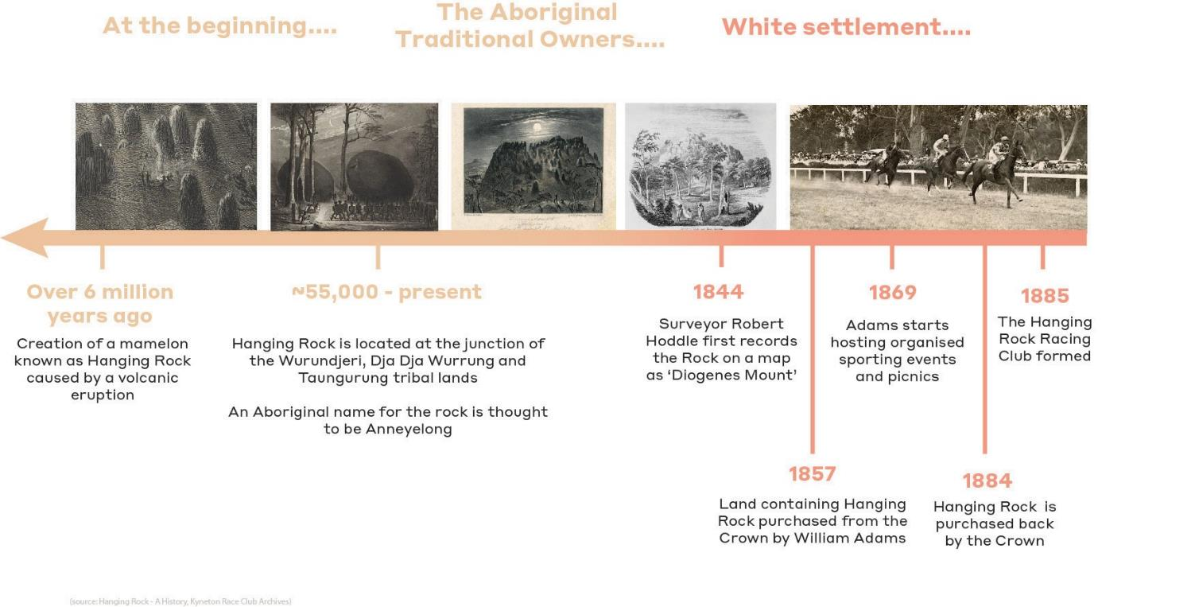

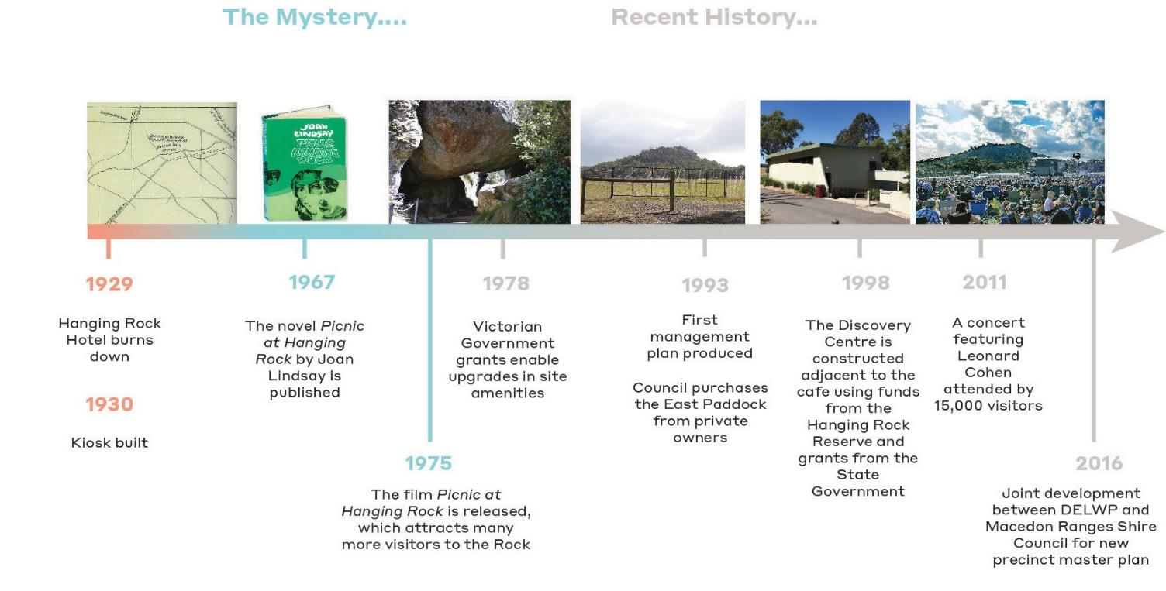

### At the beginning...

The birth of the rock formation popularly known today as Hanging Rock, occurred over six million years ago. A volcanic eruption of stiff magma through a vent in the earth’s surface caused the mamelon to form in its place. Similar, although less dramatic, mamelon formations at Camel’s Hump and Brock Monument were created at around the same time,

and together they are part of the southern end of a chain of volcanoes, beginning in Northern Queensland, which date from up to thirty-three million years ago.

Over time and likely before the first humans had arrived, the Rock had eroded and settled into its current form, at 718 metres in height. It transformed into what may have been a dense Eucalypt forest, occupied by megafauna, such as Marsupial Lions, Diprotodon, giant kangaroos and wombats.1

The three mamelons in the Macedon Ranges are the best exposures of this rock type (soda trachyte) in Australia. Significant rock formations such as this are rare, in Victoria, Australia and internationally.

Hanging Rock is now one of the most easily accessible and visible mamelon forms in the world.

1 Alexander, N (2018)

### Aboriginal Traditional Owners

Hanging Rock is located near the traditional boundary between three Aboriginal tribal groups – the Woi Wurrung (Wurundjeri), the Dja Dja Wurrung and the Taungurung. Whilst each of the traditional owner groups assert custodianship of Hanging Rock, the place has important ongoing connections and cultural values to all three groups and there are important shared values and attachments to country.

Hanging Rock is set in a broader cultural landscape, with important connections to culturally significant places and story lines at Camel’s Hump on Mt Macedon to the south, to traditional stone sources located at Coliban Dam to the north west, to Brock’s Monument and the headwaters of Deep Creek in the east, the Goulburn River to the north and Mt William to the north-east.

While records from the early European colonists are largely silent on Aboriginal use and occupation of Hanging Rock, an 1855 expedition led by naturalist William Von Blandowski and his Aboriginal travelling

companions Sandy and Mackenzie passed by the rock. In his records of the journey Blandowski gave us the Aboriginal name for Hanging Rock ‘Anneyelong’; recorded in a caption to an engraving of the rock, but likely passed to him by his companions Sandy and Mackenzie (Figure 1). It is thought by some traditional owners and linguists that the linguistically correct spelling of the name might be ‘Ngannelong’i. However, the exact meaning of the rock’s traditional name is unclear. Like so much of the history associated with Hanging Rock, there is an element of mystery and intrigue about its Aboriginal past.

Archaeological investigations carried out at Hanging Rock have discovered stone tool deposits stretching back 10,000 years in time; showing the place was occupied and used by Aboriginal people for a long period of time extending back to the end of the last Ice Age1. Some of the stone sources used to make the stone tools found at Hanging Rock come from a considerable distance, indicating the place was part of a much larger social and economic network. There is also a natural spring at Hanging Rock that provided a valuable source of water and some traditional owners believe was an important cultural and spiritual site.

Although there is no documentary evidence available about traditional Aboriginal uses of the place, it is likely that Hanging Rock featured as an important place near the boundary of the three traditional owner groups. As a prominent culturally significant landmark near tribal boundaries, the rock is likely to have been used for Ngargee ceremonies (Corroborrees) and other traditional business that involved gatherings between the three groups for marriages, resolution of conflicts, trade and initiation ceremony.

1 Vincent Clark and Associates (2014)

An insight into the likely nature of the close and inter-connected relationships that existed between the Woi Wurrung, the Dja Dja Wurrung and the Taungurung in the border zone near Hanging Rock is provided by the pioneering 19th century anthropologist Alfred William Howitt, who drew on conversations with the Woi Wurrung leader William Barak:

*‘…The Kurning-willam [Gunnung Willam Balluk] who were also Woeworung [Woi Wurrung], and whose headman was called Ningu- labul, but was named by the white men ‘Captain Turnbull’. He was a great maker of songs, which, as Berak [William Barak] said, “made people glad when they heard them”…. Ningu-labul came of a family of gifted singers, for his father and grandfather had been renowned song-makers, and this, as well as his own poetical power, was the cause of his great authority as a Ngurungaeta, not only in his own tribe, but in those adjoining. On the northern side of Mt Macedon were the Gal-gal-bulluk part of the Jajaurung [Dja Dja Wurrung] tribe, whose headman was known by the white people as “King Bobby”, and …. [he] was the “partner” of Ningu-labul. If the latter wished to bring people from further north, he sent “his word” to Bobby, who in his turn sent it on by the next near Headman…. To the westward of Ningu-labul was the country of the Kri-balluk, whose*

*Headman was a great medicine man called Doro-bauk.’*2

2 Howitt (1904)

### White Colonisation

Hanging Rock has always been a sacred place for its Traditional Owners serving as an important inter-tribal ceremonial meeting place, and a significant landmark on the boundary of three different groups – the Wurundjeri, Taungurong and Dja Dja Wurrung. European invasion smashed traditional Aboriginal life, land uses and cultural practices in the Hanging Rock area. Vast numbers of the Aboriginal population died from introduced diseases; were forced off their land and out of their homes and in some cases were killed during frontier violence and genocide. The survivors of the invasion were forcibly removed from their land and relocated to missions during the mid-late 19th century.

The first white people arrived in Melbourne in 1835. Surveyor Robert Hoddle first recorded the rock on a map as Diogenes Mount in 18433. The first map was made in 1844. The state later subdivided the land in a grid- like pattern with a lot boundary running over the eastern most cliff of the rock.

Blandowski, Curator of Melbourne’s Natural History Museum, described the rock in 1855 as ‘one of the most remarkable spots in Victoria, if not in whole Australia’.4 Not long after, it was nicknamed The Hanging Rock, for its suspended rock formation on the southern side.

In 1857, the lot containing the majority of the Hanging Rock was purchased from the Crown by William Adams, and in the 1860s it was developed for a ‘pleasure resort’. A hotel for visitors was constructed, along with a carriage track around the rock and up to the Saddle. Adams also built a lake on the creek and cleared land for a rough horse racing track. The Hanging Rock once again became a popular site for gatherings, this time for picnics.

1. McConville (2017)
2. Victorian Heritage Register (2015)

By 1869, Adams was hosting organised sporting events and picnics that begun a tradition of Boxing Day and New Years Day sports days, soon attended by thousands of visitors from the local district and beyond.

The eastern lot containing a small portion of the rock was retained by the Crown and temporarily gazetted in 1870. The Reserve was permanently gazetted for the purpose of ‘‘Public recreation and for affording access to water’’ on November 28, 18845. A formal horse racing track was laid out to the east of the rock in 1877, occupying most of the reserve, and a new north-south access road was constructed through the reserve, which remains today. The Victorian Government eventually bought the Rock and part of Smokers Creek in 1884, to extend the public reserve as a ‘Site for Public Recreation and for affording Access to Water’.

The Hanging Rock Racing Club was formed in 1885 and horse racing continued to flourish, attracting huge crowds to its biannual races. The race track was extended in 1911 to its present-day form and a hexagon- shaped ladies toilet block was built to the west, which remains today (1908).

The Hanging Rock Hotel (located near corner of Anderson and Coach Road) burnt down in 1929. It was never replaced; however, a caretaker’s cottage was built short thereafter to the south of the rock and a track was constructed up the southern side of the rock, along with steps that lead up to the hanging rock formation itself.

5 McConville (2017)

### The Mystery

In recent decades, Hanging Rock has been widely popular for its mystery and stories, thanks to the international success of the film Picnic at Hanging Rock in 1975, based on the Joan Lindsay book of the same name (1967). The film has recently been remade into a mini-series, which will no doubt result in a fresh wave of interest in the location.

The book and film are based on a story of a group of school girls from a nearby boarding school, who go missing at Hanging Rock when visiting the reserve for a picnic on Valentines Day in the early 1900s. The fictional story resulted in a huge increase in tourist numbers to the rock following release of the film. It has been speculated whether elements of the story are factual, including the disappearance of the school girls. There is no evidence to support these stories although the uncertainty about its truth adds to the mystery of Hanging Rock.

Many visitors, past and present, have described a sense of mystery about the rock and have cited unusual occurrences around the rock, such as clocks and electronics stopping, as well as the strange magnetic field in the area. This adds to the sense of intrigue and adventure of Hanging

Rock.

A new dam was constructed in 1975 in the middle of the racecourse to

### Recent History

assist with irrigation of the race track and sometimes the lawn areas in preparation for event days. Grants from the Victorian Government in 1978 enabled upgrades to various facilities, including new public toilets, picnic shelters, paths and car parking.

By the late 1980s the old tennis courts had become derelict and new courts were constructed around 1991 along South Rock Road, which is now used as the primary access point to the Hanging Rock Precinct. Local sporting clubs, including the Tennis Club, Cricket Club and Petanque Club, in addition to the Racing Club, continue to operate at the reserve.

The East Paddock eventually became a part of the precinct in 1993, offering spectacular views of Hanging Rock from the east. It can be argued that this location provides the best overall viewing point of the Rock in its entirety, away from the road. The wide-open lawns and spectacular back-drop has provided a venue to hold music concerts attracting thousands of paying spectators at a time since 2010,

often featuring well known overseas acts. The first concert featured international musician Leonard Cohen, and attracted over 15,000 visitors to the site, paving the way for a new audience to Hanging Rock and subsequent concerts of a similar size in the following years.

Over the past 20 years (since 1998), a Discovery Centre has been constructed adjacent to the cafe, along with upgrades to paths, tracks, toilets and additional picnic shelters in the East Paddock. The reserve continues to be a popular place for visitors to gather and picnic. Events

such as summer markets and vintage car meets also bring attention and vibrancy to the reserve. One of the most successful community events, the Annual Harvest Picnic, had been held at the site for over 25 years until its last one in 2013. While many visitors come to the reserve for these reasons alone, climbing and viewing the rock and enjoying the surrounds, continue as popular activities with little limitation.

The increasing numbers of visitors has brought about concerns over potential environmental impacts on the site. The preparation of the Strategic Plan will address this issue in the context for the overall vision for the Precinct.

# 3.0

GEOLOGY & ENVIRONMENT

### Geological Setting

Hanging Rock is located close to the town of Woodend in Victoria, approximately 62 kilometres north-west of Melbourne. The area is described as a “geological anomaly”, and the rock itself covers about seven hectares. The Hanging Rock Precinct covers a total of 92 hectares which includes; bushland, picnic grounds, a racecourse, café, discovery centre, cricket pitch and tennis courts. The highest point of Hanging Rock is 718 metres above sea level, which is 108 metres above the surrounding plains.

The Mamelon

The elevated areas of the Great Dividing Range within the region share the same geological origin. Mount Macedon and the Kinglake Plateau further east are comprised of rock deposited in massive volcanic eruptions around 36-370 million years ago in the Devonian era1, before erosional forces during the Cretaceous (60-130 million years ago) exposed and formed the mountain ranges2.

However, Hanging Rock is of different geological origins to its context of the surrounding ancient volcanic forms, and is “a distinctive and rare geological formation…in a unique and highly picturesque setting”3, which contributes to the site being such a popular Victorian tourist attraction.

This geological structure is known as a mamelon4, which is a rock formation created by the eruption of thick lava through a narrow vent in the bedrock below resulting in a steep-sided, rocky volcanic structure.

Hanging Rock is geologically dated back to around 6.25 million years

ago, with subsequent weathering of the radial cooling joints forming the distinctive outcrops of rock.

Hanging Rock is of National Significance as it illustrates the influence of lava composition on volcano form5 and is the best example of this

geological formation in Victoria6. It and the nearby mamelons at Camel’s Hump and Brock’s Monument constitute a distinctive, small volcanic province that has affinities with provinces in the Eastern Highlands of NSW and Queensland.

Hanging Rock is named after one formation within the mamelon, which resembles a “hanging rock” – a boulder which is suspended between two other boulders. “The Rock”, along with the surrounding scenic beauty and its associated stories and mythology, is one of the key attractions

which bring people to visit the Macedon Ranges. The site qualifies for the Victorian Heritage Database, as it is both a site of natural and cultural significance and qualifies for Criterion E - Importance in exhibiting particular aesthetic characteristics. This is due to the site being of aesthetic significance to Victoria and a location that has been recognised and enjoyed by Europeans since the 1860s for its provision of spectacular views and distinctive physical features.

1. Volcanoes in Victoria, Ben Haywood, 2008
2. Atlas Of Victoria , Duncan, J. S., 1982
3. Spirit and Earth: Setting the Scene for Experiencing Hanging Rock, Nathan Alexander, 1985
4. There is some debate whether the term mamelon is now an historic one and whether it is more correct to call it a cumulo-dome or tholoid

5 White, S (2003)

6 Rosengren, N & Joyce, E (2018)

Figure 4. Topographical Setting of Hanging Rock

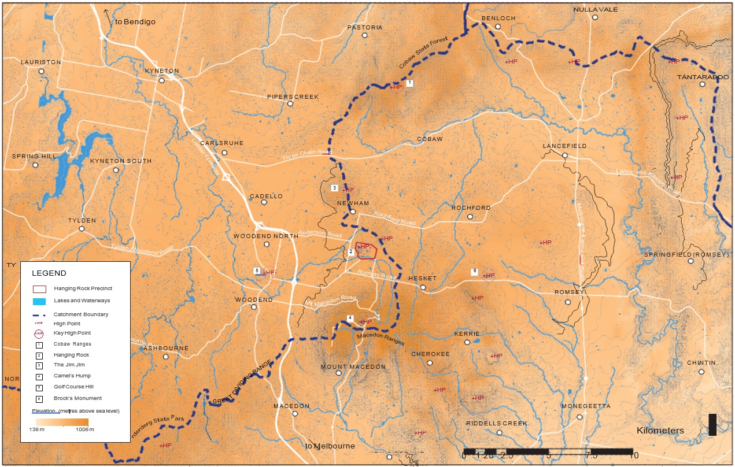

### Landscape Setting

The Macedon Ranges

Hanging Rock is dominated by its surrounding landscape, which contributes significantly to the Macedon Ranges region. The Macedon Ranges have recently been recognised as a Distinctive Area and Landscape under the Planning and Environment (Distinctive Areas and Landscapes) Act 2018.

The topographical context of the surrounding landscape is that of the Great Dividing Range, which is a substantial system of mountain ranges that follows the coastline south from the north-eastern tip of Queensland to Victoria before turning west and fading into the central plain west of the Grampians. The Great Dividing Range extends locally through the Macedon Ranges region, from the Yarra Ranges and Kinglake Plateau to the east, taking in Mount Macedon and the Cobaw Range as well as the plains in between, and then out west through the Pyrete Range of the Lerderderg State Park .

Significantly, the Hanging Rock Precinct is located on the crest of the range, which delineates the boundary between land draining to the south (Maribyrnong and Werribee catchments) and land draining to the north to the north (Coliban, Campaspe and Goulburn catchments). As shown on the map on page 17, this line runs from the Pyrete Range across Mount Macedon, before descending to the north in between Falls Creek (west) and Garden Hut Creek (east). The crest continues northwards and passes over the hill located approximately 1km north-east of Hanging Rock,

and continues north-west to the Jim Jim. From the Jim Jim the crest extends north and then east across the Cobaw Ranges, and then further east over Mount William and into the Kinglake Plateau. Many of these high points are recognised as sites of national, state, regional and local

geological significance in the planning scheme (Clause 21.05-2 Significant environments and landscapes).

As a landscape setting, the Macedon Ranges and Hanging Rock area is of state significance, with exceptional landscape features, edges and contrast, and compositional values1.

The Macedon Ranges has increasingly become under pressure for growth and change due to its high aesthetic values, accessibility and its proximity to Melbourne. However, the region plays an important role in the state for tourism, agribusiness and lifestyle, linked strongly to Melbourne. The key values, attributes and activities of the region require recognition and protection to ensure they can continue to be accessible and enjoyed well into the future.

The Macedon Ranges Statement of Planning Policy has been prepared by the State government in collaboration with local government, to protect these areas, including Hanging Rock and all its surrounds and view lines.

The Macedon Ranges encompass several towns and villages that service Hanging Rock, with Woodend being the closest town (8.4km) providing ancillary services to visitors and residents nearby the Rock.

Hanging Rock is central to the Macedon Ranges, just north of Mount Macedon and the Macedon Regional Park and provides a way-finding point for many travelling through the region. The ranges consist of mostly undulating farmland, with pockets of forests and rural residential properties in between the major towns.

1 Claire Scott Planning (2018)

The Rock itself sits within the Hanging Rock Precinct, which caters to a wide range of activities. The bushland component of the reserve is

approximately 24 hectares, found at the base of the Rock2 and is one of the last remaining areas of uncleared land between the Macedon Ranges and the Cobaws. The northern and southern sides of the sloping bushland are varied, with the north being mostly open woodland with dense vegetation at the base of the Rock, while the southern slopes are denser owing to the cooler micro-climate in the shadow of the Rock.

2 Alexander (1985)

### Ecological Setting

##### Bioregions and Ecology

Bioregions are large, geographically distinct areas of land with common characteristics such as geology, landform patterns, climate, ecological features and plant and animal communities. The Interim Biogeographic Regionalisation for Australia (IBRA) is a system of bioregional classification applied across the country.

The Macedon Ranges region is located within the Central Victorian Uplands bioregion, which is characterised by dissected Palaeozoic sedimentary, volcanic, granitic and metamorphic rocks, manifesting as a gently undulating terrain1. At one time, this bioregion may have supported tall, open forests or open forest native vegetation formations, with the lower slopes of the uplands suited to grazing and cropping. This landform is prone to sheet and gully erosion and salting.

1 Duncan, J. S., (1982)

Figure 5. Bioregional Setting of Hanging Rock

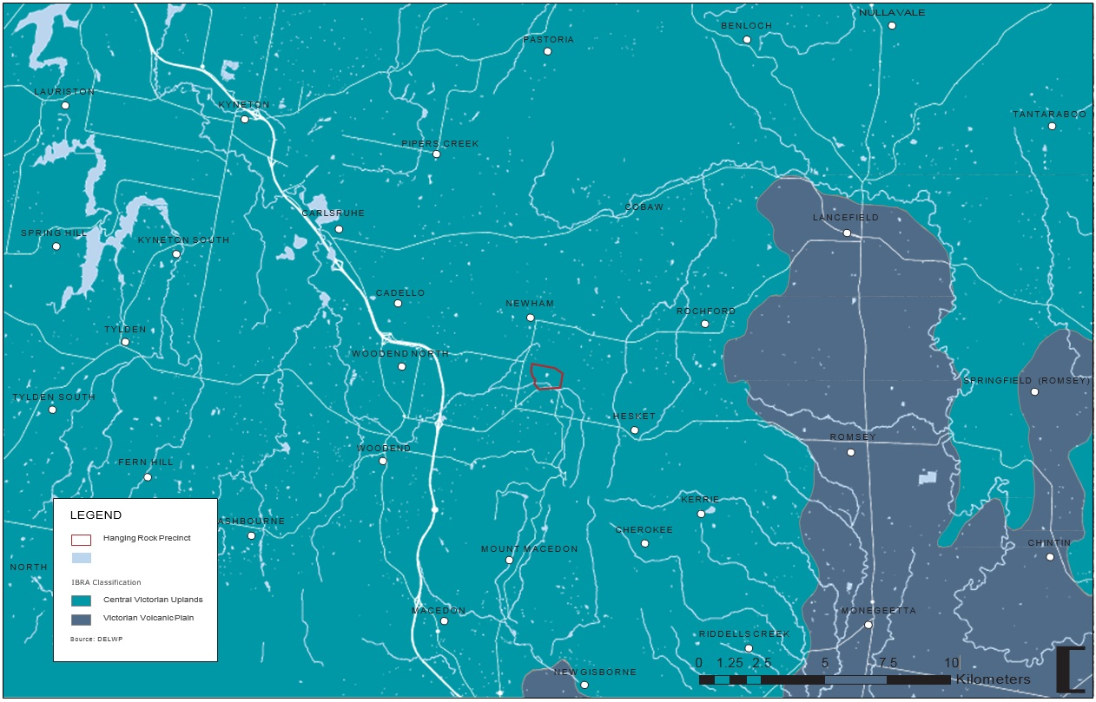

The Cobaw Biolink is a network of native vegetation connecting two large areas of public land, the Macedon Regional Park and the Cobaw State Forest.

Hanging Rock Reserve is one of the few larger patches of remnant vegetation in the plains between Mount Macedon and the Cobaw Range. As well as contributing to the local landscape values of the rock, this native vegetation is a regionally important ‘stepping stone’ for landscape connectivity due to its size and the presence of multiple Ecological Vegetation Classes, which provide diverse habitat values for wildlife2.

The biolink, situated at the southern end of the Great Dividing Range and including upper catchment areas of both the Campaspe and Maribyrnong river systems, is extremely important for biodiversity within Victoria, especially in a time of climate change.

The Macedon Ranges Shire has identified the area between the Cobaw Range and Mount Macedon as the Cobaw Biolink in its Planning Scheme, and supports this through policy.

Landscape scale connectivity on the western side of the biolink, to ‘tie in’ remnant vegetation at Hanging Rock Reserve and on the Jim Jim, is being achieved through riparian restoration and extensive works on private land. The remnant vegetation of Hanging Rock Reserve is an important component within this link3.

1. Practical Ecology (2015)
2. Practical Ecology (2015)

Figure 6. Cobaw Biolink

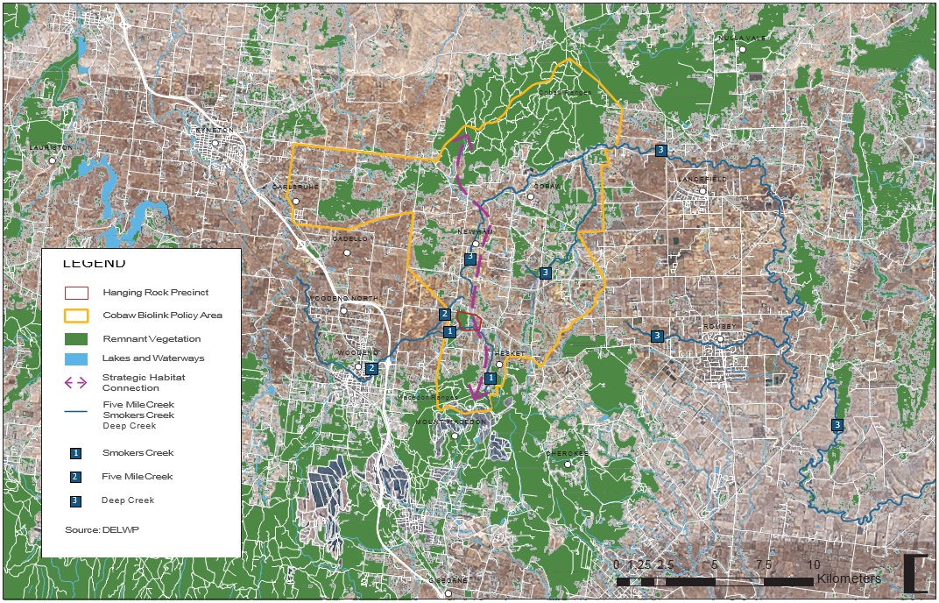

##### Flora

Ecological Vegetation Classes (EVCs)

The pre-1750 EVC mapping on page 30 shows the regional context of the Hanging Rock Precinct, with the main features being the Herb-rich

Foothill Forest (light purple) of the foothills of Mt Macedon in the southern half and the Cobaw Ranges in the north. The area in between these higher landforms was characterised by the Valley Grassy Forest (light orange) centrally with Plains Grassy Woodland (grey-green) also in the flatter plains to the east and west. The Valley Grassy Forest is broken up by areas of Scoria Cone Woodland (darker purple) of the higher areas of volcanic cones such as the Jim Jim, and the Swampy Riparian Woodland (green) and Creekline Herb-rich Woodland (darker green) of riparian corridors.

In the immediate context of the Hanging Rock Precinct, the pre-1750 mapping shows the Precinct within the Herb-rich Foothills Forest of the lower slopes of Mt Macedon, with a small area of Swampy Riparian Woodland at the southern extent around Smokers Creek. Just north- west of the Precinct is mapped as Plains Grassy Woodland.

The 2005 EVC mapping on page 31 shows the slopes of Mt Macedon and the Cobaw ranges as the largest areas of intact remnant vegetation in the study area, with the lower and flatter land of the plains in between extensively cleared. The Hanging Rock Precinct shows as a large patch of remnant vegetation in this cleared landscape, as well as the Scoria Cone Woodland of the Jim Jim and the Plains Grassy Woodland / Grassy Forest around Newham. The 2005 mapping shows the Precinct as largely covered by Herb-rich Foothill Forest, other than the Swampy Riparian

Woodland in the south and an area of Montane Grassy Woodland / Rocky

Outcrop Shrubland / Rocky Outcrop Herbland Mosaic on the upper slopes of the rock. However, the 2015 EMP1 identifies that the Precinct comprises a more detailed set of EVC areas that used to naturally occur in different areas of the Precinct, based on the existing remnant vegetation (see mapping on page 34):

* EVC 859 Montane Grassy Woodland (EVC37) / Rocky Outcrop Shrubland/Rocky Outcrop Herbland Mosaic (EVC73)– on upper areas of rock formation

(EVC859 status not available, EVC37: Vulnerable, EVC73: Least Concern)

* EVC 55 Plains Grassy Woodland – along the boundaries at the north- western corner of site

(Endangered in bioregion)

* EVC 23 Herb-rich Foothill Forest – southern and eastern slopes of rock, and East Paddock connected by thin strip along northern boundary above the racecourse

(Depleted in bioregion)

* ECV 23 / EVC 55 Transition Zone – northern and western lower slopes of the rock
* EVC 23/EVC 55 Racecourse Grassland – racecourse area (once probably a mosaic between the three nearby EVCs: Plains Grassy Woodland, Herb-rich Foothill Forest and Swamp Riparian Woodland)
* EVC 83 Swampy Riparian Woodland – approx. 200m either side of Smokers Creek, extending northward to take in cricket oval. (Endangered in bioregion)

1 Practical Ecology (2015)

The status of all of the EVCs existing at the reserve are threatened to some extent, with EVC 55: Plains Grassy Woodland and ECV 83: Swampy Riparian Woodland endangered within the Central Victorian Uplands.

Due to vegetation fragmentation and clearing in the Hanging Rock region and the functional form of the Precinct as a large patch of remnant vegetation, most of the indigenous flora species are considered to be

of at least local significance, however there are also several species of regional significance and two rare / threatened flora species of state significance2.

The ecological condition across the Precinct differs, with an assessment of the extent and quality of indigenous ground-storey vegetation cover illustrating that the drier environments are in better ecological condition that the moister areas. For instance the ‘core area of the rock formation and its northern slopes are represented by greater than 75% cover of indigenous vegetation species, as compared to the 25-50% cover of the southern slopes where a moister environment allows weeds to take hold following decades of impacts’3. The ecological condition of the racecourse grassland is also relatively poor, degraded and infested with exotic grasses and herbaceous species.

Species of State Significance

The Dwarf Silver-wattle (*Acacia nano-dealbata*) is found in patches around the sides of the rock formation, in particular around the eastern lookout. The Dwarf Silver-wattle is listed as Rare on the Victorian Register of Threatened Species (VROTS).

1. Practical Ecology (2015)
2. Practical Ecology (2015)

There is a patch of approximately 10 young Black Gums (*Eucalyptus aggregata*) in the East Paddock along Smokers Creek. Black Gums are listed as vulnerable on the EPBC Act List of Threatened Flora,

endangered on the VROTS, and is listed under the State Flora and Fauna Guarantee Act 1998.

Species of Regional Significance / Botanical Interest

There is a population of Snow Gums (*Eucalyptus pauciflora*) growing on the rock formation and in the racecourse grassland. These Snow Gums would be the lowland form, growing below 1,300m in elevation, and as such are of botanical significance as there are thought to be few stands remaining of this form across Victoria. Snow Gums are also of habitat value for Koalas.

A patch of mature Silver Banksias (*Banksia marginata*) in tree form is growing near the summit of the rock. The tree form of Silver Banksia has almost completely disappeared from its habitat in Victoria owing to clearing, and as such this patch is of botanical significance.

There is a population of Leafy Fireweed (*Senecio squarrosus*) in the grasslands of the racecourse. Leafy Fireweed is an uncommon plant within the state, and a population of 20-40 individuals is of botanical significance.

The 2015 Hanging Rock Environmental Management Plan considers it likely that many of the species recorded at the Precinct would be of

regional significance, as determined by having a frequency of occurrence of less than 5% across the Central Victorian Uplands. However, the compilation of a regionally significant flora species list was not compiled as part of the EMP.

Figure 7. Ecological Vegetation Classes pre-1750

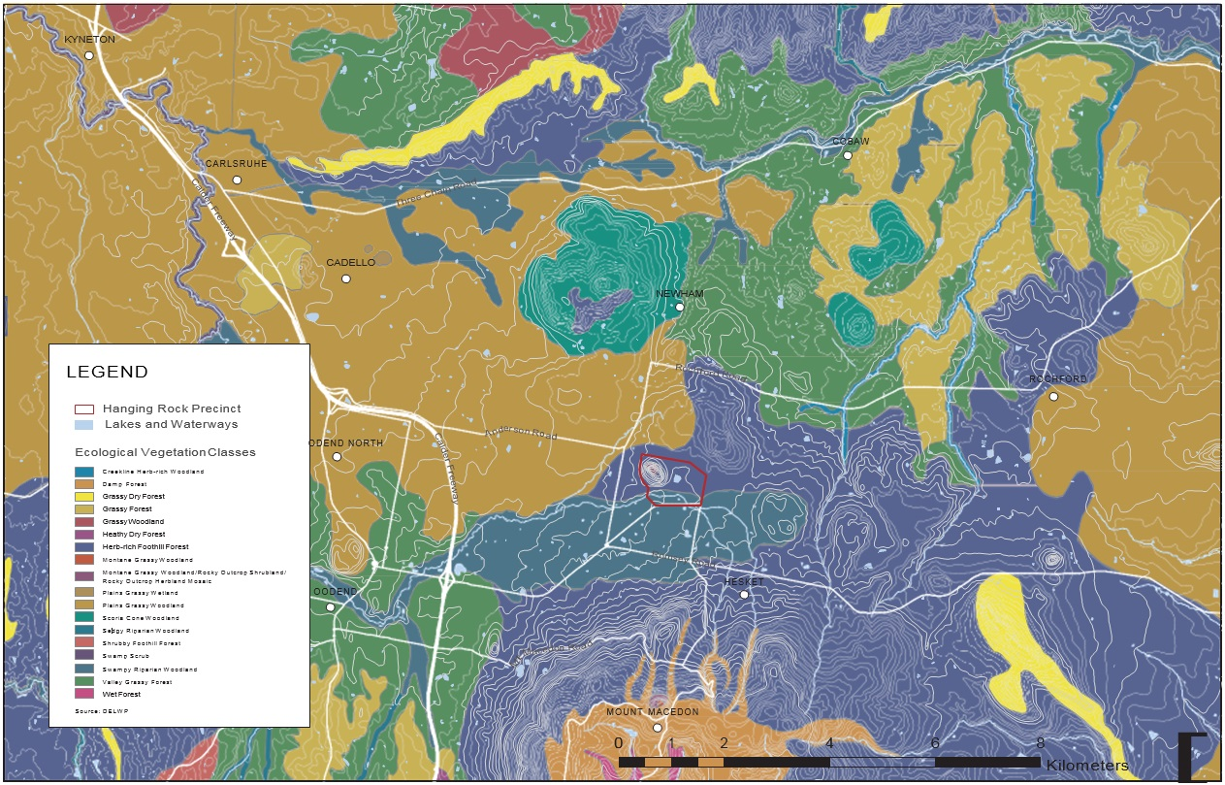

Figure 8. Ecological Vegetation Classes in 2005

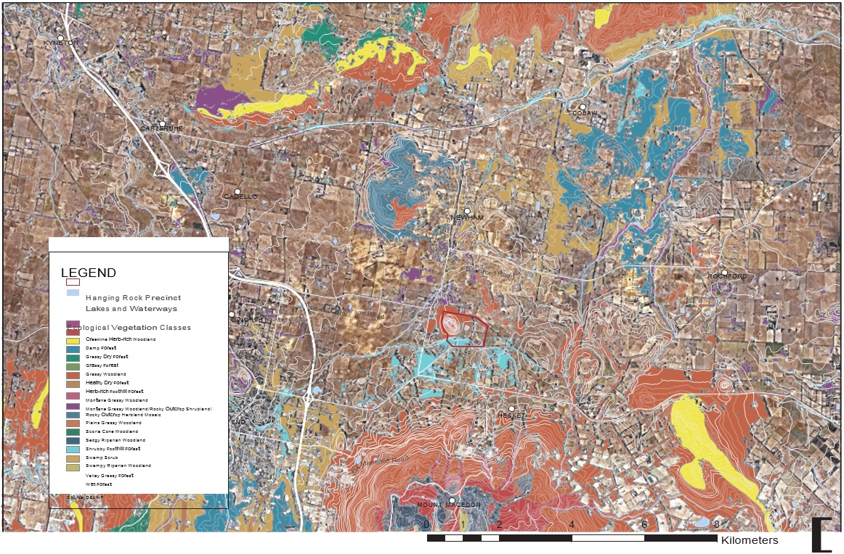

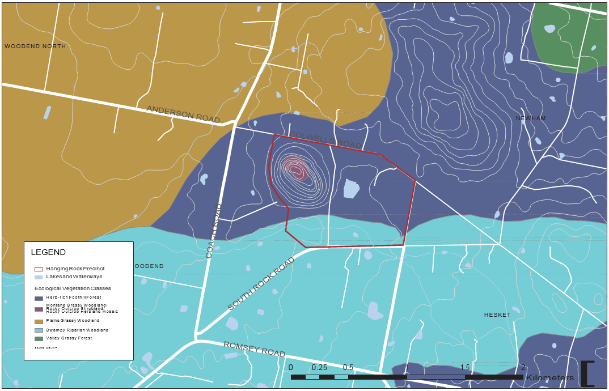

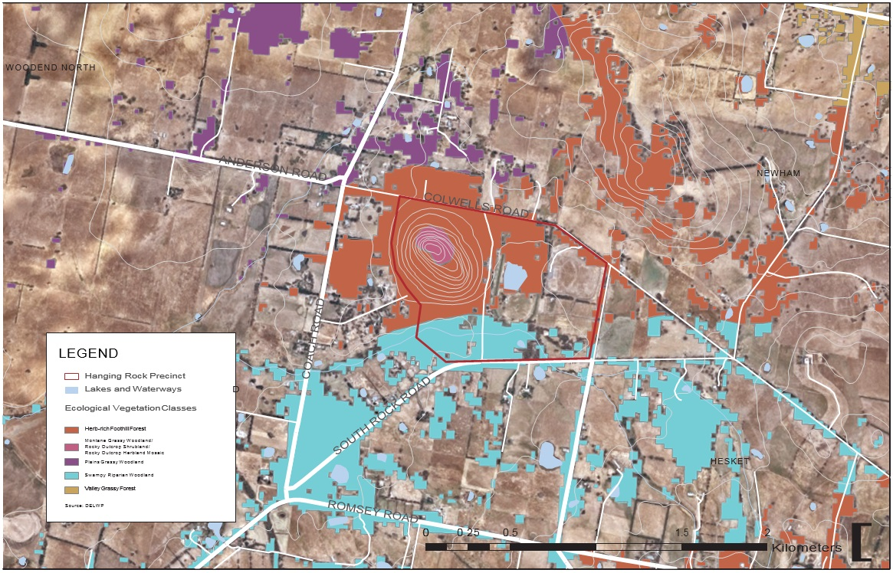

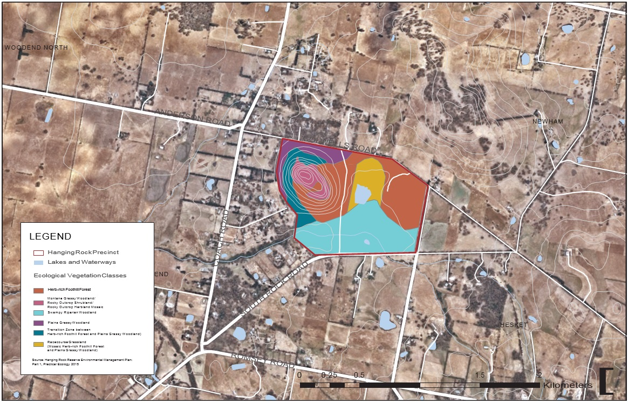

##### Fauna

As noted above, the significant patch of remnant vegetation contains numerous habitat values in itself, and is also an important habitat ‘stepping stone’ regionally. The Victorian Biodiversity Atlas identifies 692 records for fauna species within 5000m of the Reserve. Of these, five species are listed nationally under the EPBC Act (one Critically Endangered, two Endangered, and two Vulnerable). 25 species are listed

on the Victorian Advisory List (six Endangered, 10 Vulnerable, three Near Threatened, and six Rare).

The 2015 EMP found that compiled fauna data confirmed that Hanging Rock supports a diverse ranges of fauna species and habitats. In terms of the habitats, the following were observed:

* + Waterbodies (Racecourse Dam and the other four smaller dams)
  + Riparian corridor (Smokers Creek)
  + Open grassy areas (racecourse grassland, East Paddock, picnic areas)
  + Forested areas (the base and slopes of the rock formation)
  + Dense shrubby areas (around the southern slopes and base of the rock)
  + Rocky areas and cliff faces, and
  + Single and patches of large old trees

The following is a list of threatened fauna species recorded within the Reserve, compiled from the limited 2015 EMP fieldwork and additional other sources:

Figure 12. Threatened Fauna Species

|  |  |
| --- | --- |
| Species Status | Species Status |
| Grey Goshawk Vulnerable in Victoria  *Accipiter novaehollandiae* Listed under the FFG Act (1998)  *novaehollandiae* | Swift Parrot Endangered in Victoria  Lathamus discolour Listed under the FFG Act (1988) Endangered species under the EPBC |
| Australasian Shoveler Vulnerable in Victoria  *Anas rhynchotis* | Act (1999)  Barking Owl Endangered in Victoria |
| Eastern Great Egret Vulnerable in Victoria  *Ardea modesta* Listed under the FFG Act (1988) | Ninox connivens connivens Listed under the FFG Act (1988) Powerful Owl Vulnerable in Victoria |
| Hardhead Vulnerable in Victoria  *Aythya australis* | Ninox strenua Listed under the FFG Act (1988)  Greater Glider Vulnerable in Victoria |
| Brown Treecreeper (south- Near threatened in Victoria eastern ssp.)  *Climacteris picumnus victoriae* | *Petauroides volans*  Brush-tailed Phascogale Vulnerable in Victoria Phascogale tapaotafa |
|  |  |
| Latham’s Snipe Near threatened in Victoria  *Gallinago hardwickii* Migratory species under the EPBC  (1999) | Two additional species are considered significant under the classification Act of fauna-iconic species, despite not being threatened. |
|  | The koala (*Phascolarctos cinereus*) is of historical and tourism value to the Hanging Rock and the Macedon Area. |
|  | A pair of Peregrin Falcons (*Falco peregrinus*) nests at Hanging Rock, |
|  |  |
|  |  |
|  |  |
|  |  |
|  |  |
| White-throated Needletail Vulnerable in Victoria  *Hirundapus caudacutus* Migratory species under the EPBC  (1999) | The Koala (*Phascolarctos cinereus*) is of historical and tourism value to  Hanging Rock and the Macedon area.  Act  A pair of Peregrin Falcons (*Falco peregrinus*) nests at Hanging Rock, |

###### 

indicating another level of biological diversity within the Reserve and the use of specialised habitat niches. It is important to protect breeding pairs, and plan around factors such as breeding cycles and habitat requirements.

##### Waterways

The Macedon Ranges region straddles the Great Dividing Range, and as noted previously the crest of this range runs closely by Hanging Rock. This crest defines the extent of the water catchments in the region, meaning that land to the north/west drains north to the Murray River, and land

to the south/east drains south to Port Phillip Bay. More specifically, the land around Hanging Rock drains in two primary directions into sub- catchments of the above catchments:

* The reserve and land to its south and west is part of the Campaspe River catchment, part of the Murray River catchment, draining to the south-west via Smokers Creek and Five Mile Creeks, before joining the north flowing Campaspe a couple of kilometres west of Woodend.
* The land north and east of the reserve drain to the north via the many tributaries of Deep Creek, which flows initially north before turning east and then south around Lancefield and flowing south all the

way down just east of Tullamarine airport where Deep Creek meets Jacksons Creek and becomes the Maribyrnong River which drains into Port Phillip Bay via a short stretch of the Yarra River.

The Campaspe River catchment is one of four sub-catchments of the North Central region, and is governed by the North Central Catchment Management Authority (NCCMA) and as such is subject to the North Central Waterways Strategy1. The strategy rates the waterway condition of Five Mile Creek (encompassing the tributary of Smokers Creek) as

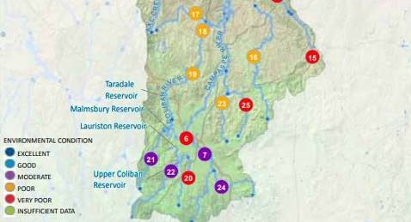

Hanging Rock Reserve

Above image: Upper Campaspe River catchment (modified from North Central Waterway Strategy 2014-2022). Five Mile Creek denoted by the number 24

Moderate2, and identifies this stretch as a Priority Waterway with the following long-term management objectives:

* Improve the condition of the Five Mile Creek to good by 2050.
* Improve the condition of the riparian zone of Five Mile Creek by 2021

1 NCCMA (2014)

2 As determined by the statewide Index of Stream Condition (ISC) which provides the most comprehensive statewide set of information available on waterway condition.

The Precinct itself drains via Smokers Creek, other than the north and western slopes of the rock which drain to Five Mile Creek in the north- west. Smokers Creek flows east to west along the southern boundary of the Precinct. Smokers Creek, and a number of smaller tributaries that feed it, drain the northern slopes of Mount Macedon. These drainage lines enter the site from the south under South Rock Road, and also in one location under Straws Lane.

There are also two additional drainage lines that enter the site from the north, draining a few hundred metres south of the Great Dividing Range crest, and flowing into the Racecourse Dam. This is the largest dam within the reserve, and currently used to irrigate the racecourse for the two January racing events, as well as the East Paddock for the concerts in summer. This dam is supplemented by water pumped from Smokers Creek during spring. Prior to the construction of the dam in

1975 the drainage lines that feed it would have previously been tributaries connecting south of the dam to Smokers Creek. The Racecourse Dam has habitat values for four threatened wetland bird species, and is also used by other indigenous fauna.

Three smaller dams are also located along / adjacent to the alignment of Smokers Creek, and one further dam is located in the north-west

corner of the East Paddock parcel. None of these dams are used to water areas of the Precinct, however some have ecological values in terms of indigenous wetland plant and bird habitat. Although dams, fish barriers and creek diversions can also result in environmental problems.

Smokers Creek was a permanently flowing creek, although it now often ceases to flow over summer. The reasons for this are reduced water flows across the entire catchment and the retention of water in new

dams constructed across the landscape1. Smokers Creek is an important riparian link across the landscape, and part of the Cobaw biolink.

A permanent water source is located in between the Rock and the racecourse, mapped by Robert Hoddle2 as ‘Spring’ in 18433. The spring/ well is now lined with brick.

An additional alternative water supply is being proposed by Woodend’s Recycled Water Plant, which produces Class C recycled water. Much of this excess water is released to Five Mile Creek, which could be

used to irrigate and sustain the Hanging Rock Reserve. This would reduce reliance on the creek and dam while enhancing the site’s climate resilience. The proposal is being considered by Western Water for 2020.

In addition to the above ecological and environmental values, water plays an important cultural and historical role at Hanging Rock. The permanent water sources of Smokers Creek and the spring/well were important to the cultural and spiritual use of the site by Aboriginal people4. Following colonisation and the clearing of land for grazing, the Reserve was valued by farmers and grazers as a reliable supply of summer water, and was initially declared a recreation and water reserve5. The creation of a

lake (now at 99 South Rock Road, no longer part of the Reserve) in 1869 by constructing a weir across the creek was part of the creation of a ‘pleasure resort’ at the Reserve6. This lake reportedly catered for rowing boats and imported swans and other birds7, demonstrating the role that water played in the Reserve’s historical recreational value.

1. Practical Ecology (2015)
2. McConville, C (2017)
3. (It is not clear whether or not this is a naturally occurring spring or an excavated well)
4. Alexander, N (2018)
5. McConville, C (2017)
6. Alexander, N (2018)
7. Victorian Heritage Register (2015)

### Visual Setting

##### Overview of Visual Character

Visual character is defined as the interplay between built and natural features, the extent of the viewing distance, public view corridors, vistas, and the effect of the pattern of viewing. The following are the main elements of the area’s visual character:

* + Typical views of the area are long views across agricultural landscapes with grazing fields in the area reflecting the fertility of the land;
  + Views to Hanging Rock are provided within a broad visual catchment extending north from the northern slopes of Mt Macedon to the southern slopes of the Cobaw Ranges, and east from the Calder Freeway to the elevated areas around Rochford in the west. A second local catchment within a radius of 2-3km of Hanging Rock provides exemplary views of the rock rising as a feature in the fore and mid- ground;
  + Filtered and intermittent glimpses of Hanging Rock seen from the road through trees, vegetation or fencing (particularly from approaches coming from the North, West, and East) contribute to the Rock’s sense of mystique and intrigue;
  + Views towards Hanging Rock are intermittent because of vegetation along the road, with the most striking and emblematic views coming from the closer range approach on roads oriented toward the rock, such as Anderson Road (west) and Colwells Road (east);
* In views where the formation is a feature in the middle ground, the

formation stands out in stark contrast from other elements because of its dramatic topography rising from the otherwise relative flatness of the landscape north of Mount Macedon. The exposed rocky face is also a stunning and unique feature that is visible above the agricultural landscape and is a defining feature of the area;

* Natural lighting conditions contribute to Hanging Rock being the prominent element in the frame because of the effect of the light on its rock/face, with sunrise and sunset providing significantly different experiences of viewing from the east and west; and
* Elevated vantage points such as Mount Macedon and the Cobaw Ranges afford panoramic views and an appreciation for the wider landscape context, within which the scale of Hanging Rock is diminished and the feature is not a primary focal point.

##### Types of Views

The significant views in the study area are generally divided between those which look over the rural landscape, focusing on land forms such as Hanging Rock (and Mount Macedon), or those looking outwards from locations within or on Hanging Rock. Within these, there are short and

long-range views, which reflect the variety of viewing distances which are visible from the viewing location.

Significant short-range views of Hanging Rock have the formation as the primary focal point of the horizon, with details of its feature clearly visible. These views are typically framed by roadside vegetation that otherwise filter views to the rock.

Significant long range views focusing on Hanging Rock are those featuring the formation in the midground where it is read as part of the wider landscape and larger topographical features. They are often specific glimpses of Hanging Rock where allowed by other elements in the composition such as vegetation or the topography of the area, or extended views along key approach roads.

Other than views to the Rock itself, the significant views from the Precinct are long-range views, made up of broad vistas and panoramas across the surrounding landscape of the Macedon Ranges from the higher elevations of these viewing locations. From the Rock itself exploration is an intrinsic character of these views as glimpses of the broader landscape are afforded through, around or in between framing boulders, and then unfold into wide vistas and panoramas (including those of Mount Macedon) the closer the viewing location is to the edge or to the Summit of Hanging Rock.

##### Culturally Important Views

The viewshed to the south, south-east and west of the East Paddock is culturally important to Aboriginal Traditional Ownbers as it draws in

other important features of the cultural landscape surrounding Hanging Rock.

The key viewlines between the features of Hanging Rock, Camel’s Hump and Brock’s Monument are also culturally important.

The viewshed from the East Paddock within this culturally important field of view, as well as the culturally important viewlines are represented on the following map.

Figure 13. Culturally Important Views & Visual Connections

LEGEND

Hanging Rock Precinct

Culturally Important Field of View from East Paddock

Mapped Viewshed within Culturally Important View from East Paddock

Mapped Viewshed from East Paddock

Culturally Important Viewlines

Based on Extent Heritage Advisors - Hanging Rock Aboriginal Values and Mapping

Hanging Rock

East Paddock

Brock’s Monument

Camel’s Hump

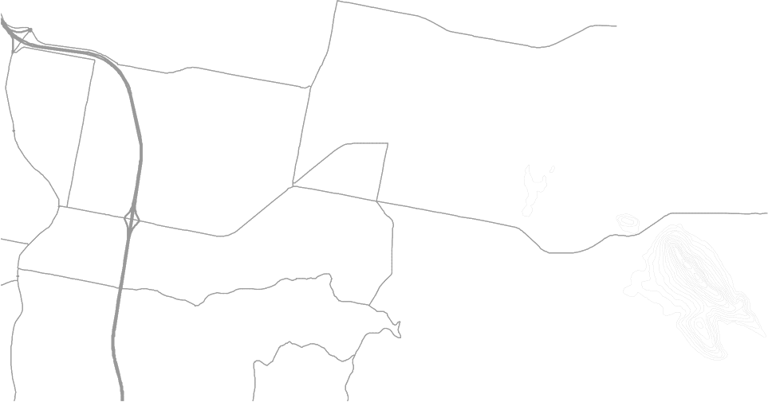

0 0.475 0.95 1.9 2.85 3.8

[

Kilometers

|  |  |  |  |  |  |  |
| --- | --- | --- | --- | --- | --- | --- |
|  |  |  |  |  |  |  |

Figure 14. Significant Views

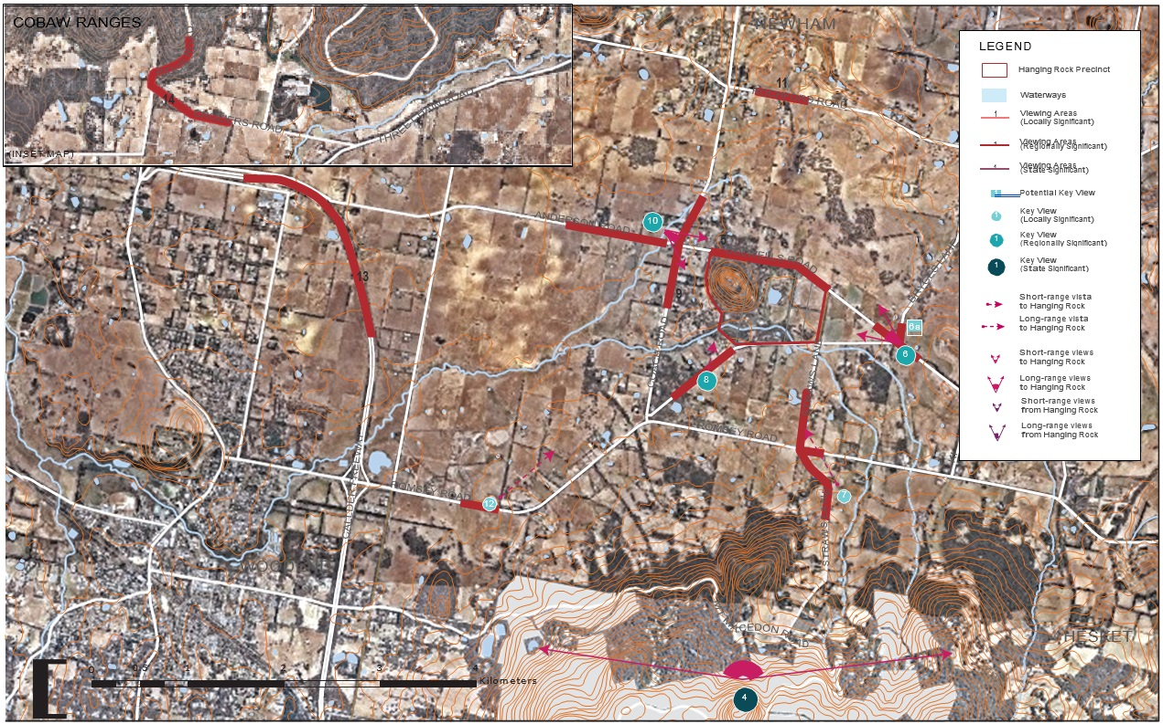

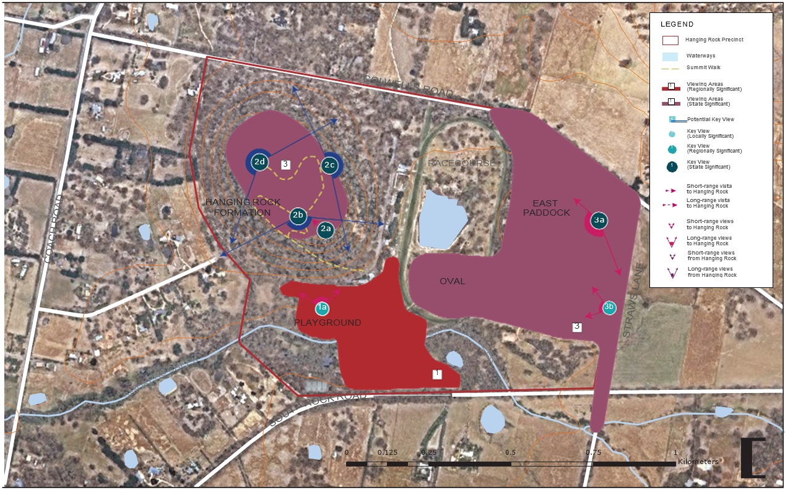

##### Key Views

Certain views of Hanging Rock were found to be significant based on fulfilment of criteria that includes an assessment of their aesthetic quality, composition, and values including their social, cultural, historic, and environmental, among others. Among these, potential view sites have also been identified where there are good views of Hanging Rock but its current use poses some limitations for this view to become more recognised.

This visual analysis draws on the assessment of the views of significance within the *Macedon Ranges Landscape Assessment & Implementation: Landscape Values & Significance* report1, which assesses the significance of the views within the entire Macedon Ranges Shire. The assessment considers views of the Macedon Ranges wider landscape, whereas the visual analysis contained within this strategic plan focuses on views associated with the Hanging Rock Precinct only (both those to and from the Precinct and rock feature). Regardless, there are two views that are identified within both documents, the views from Camel’s Hump and the Hanging Rock Summit (views 12 and 3 in this document).

1 Claire Scott Planning, (2018) (Draft)

Views of Significance

State Significant Views

* + Views of The Hanging Rock (2a)
  + Views from the Hanging Rock Summit Walk (2b, 2c & 2d)
  + View from the East Paddock (3a)
  + View from Camel’s Hump

Regionally Significant Views

* + Views from the Southern Hanging Rock Precinct (1)
  + Views from Straws Lane (3b)
  + Views from Colwells Road (East) (6)
  + Views from South Rock Road (8)
  + Views from Anderson Road (10)

Locally Significant Views (provided in Appendix 1)

* + Views from Colwells Road (North) (5)
  + View from Straws Lane (South) (7)
  + Views from Coach Road (9)
  + Views from Rochford Road (11)
  + Views from Romsey Road (12)
  + Views from the Calder Freeway (13)
  + Views from the Cobaw Ranges Foothills (14)

Area 1 - Southern Hanging Rock Precinct

This area immediately south of the formation offers classic views of the formation from key park infrastructure. Its proximity to the formation allows for a closer inspection at the details of the boulders rarely seen from other viewing opportunities. As it is at a slightly lower elevation, the scale of Hanging Rock is even more apparent from this angle as the

viewer is dwarfed by the trees in the foreground and the boulders in front appear to be much larger as they obscure the peaks of the summit. Initial views of the formation are seen from this location as you enter from South Rock Road. This viewing area is one of a kind as Hanging Rock is viewed as a striking group of boulders that form part of the forest, rather than its typical views as a mamelon within the rural landscape.

This location includes the entrance and arrival zone south of the rock formation, including the entrance road, car park, recreational spaces, discovery centre / café and playground. From this location, the details of the Rock formation’s boulders and its majestic scale are more observable as it is seen from slightly above eye level within a close distance. The peaks of the formation are obscured in this view by a forest of boulders and tall trees, although some peaks become slightly more visible from certain angles. At the start of the Summit Walk, this view is symbolic as the first view before an attempt to summit is made.

Significance - The views of Hanging Rock from this area are of regional significance as they are often depicted in art and illustrative of the cultural heritage importance in its historical use as a sacred meeting place.

The view from the Playground (1a on Figure 15) is representative of the types of views from this viewing area.

Area 2 - Hanging Rock and Summit Walk

The rock formation of the mamelon itself is not only an important subject of views, but also an area that affords significant views both within

and externally to the wider landscape of the Macedon Ranges. There are two types of views associated with the Hanging Rock and Summit

viewing area, the specific view of the Hanging Rock feature itself, and the multiplicity of views to the wider landscape from elevated vantage points along the summit walk.

The Hanging Rock (View 2a)

One of the first encounters along the Summit Walk is the boulder which lends its name to the site, The Hanging Rock. Several access challenges for this view site include its location on a narrow staircase and a low height clearance beneath the suspended boulder. The subject is normally viewed on the way up the track, and as this perspective is from a lower angle, there is an appreciation of the boulder’s mass and scale and it can be clearly seen that the boulder is suspended.

The view is a specific view of the rock feature, framed by vegetation and adjacent rock fingers, with the elements of the path leading through and under the main focal point of the rock itself. The patina and texture of the rock is a key feature of this view, with the orange underside contrasting with the greens in surrounding vegetation and rock formations.

To appreciate this view of the Hanging Rock, the viewer must pause at a point on the trail below the rock, and adequate distance at which the entirety of the feature can be taken in, which causes potential conflicts with users of the path moving through.

This view is of state significance as it is a one-off view that best shows the famous boulder on the Summit Walk.

The Summit Walk (Views 2b, 2c & 2d)

The summit walk offers a multiplicity of viewing experiences to the wider landscape between the Stonehenge area at the southern end of the rock formation, and the summit at the north-western end. The three main viewpoints from on top of Hanging Rock are described individually below, though to prescribe a significance rating are considered as a collective.

The views along the summit walk are intrinsically linked to the exploratory nature of the walk, with the viewer drawn further along the walk to gain elevation seeking the elusive panorama hinted at various points and finally revealed in part at Morgan’s Lookout and in totality at the Summit. Each viewpoint typically offers a multiplicity of viewing experiences given the prominence of the boulders as foreground elements, though these can

be broadly described as either exploratory framed and filtered glimpses and views, to wider panoramas from elevated vantage points. The views reveal exemplary views of the rural landscape transitioning from the dark forested areas and topographical features such as Mt Macedon, Brock’s Monument and the distant Cobaw Ranges, to the yellows and greens of the geometrically defined rural pasture. Housing and small buildings are scattered throughout the landscape, providing an important sense of scale to the view and reinforcing the rural character of the view.

The views from Hanging Rock Summit Walk are considered State Significant given the culturally important visual connections to Camel’s Hump and Brock’s Monument, the presence of the iconic geological formation in the foreground of these views, and the dramatic rise in elevation that provides a rare view from an elevated position of the bulk of Mount Macedon rising from the lower plains below. The view to the

west, north and east over the expansive plains further afield are similarly rare, with the sharp topographical rise providing a vantage point that seemingly floats over the surrounding landscape, particularly where historic recreational infrastructure of the racetrack forms the mid- ground to the east.

Stonehenge at Hanging Rock (View 2b)

Along the Summit Walk, this area of clearing looking towards southwest is important as it offers the first designated lookout point on the route. From here, the view is of the boulders in the foreground with glimpses of the landscape and the peaks of Mount Macedon from beyond the tops of the boulders. The interrupted vistas incentivise exploration such as climbing boulders to seek higher elevated places to gain a full view of the landscape, however this is not easily achieved.

The Saddle at Hanging Rock (including Lover’s Leap, View 2c)

Being at the midpoint of the Summit Walk, the Saddle is at an elevation high enough for long-ranging views of the surrounding hills framed by boulders in the foreground. This makes a unique view as the barren rock in the foreground contrasts greatly with the vegetated landscape in the background. The views in this composition contribute to the mystique of Hanging Rock wherein boulders seem to hide and reveal elements from every turn. Moreover, this vista is also exceptionally significant because it is taken from the only location providing views of the areas of the racecourse and East Paddock just below; venturing off the designated track and towards the edges provides more complete the views of these areas beneath.

Morgan’s Lookout at Hanging Rock (View 2d)

As a destination at the end of the Summit Walk, Morgan’s Lookout is located at the north-western end and highest point of the rock

formation. It provides a unique and exceptional 360 degree panorama of the landscape surrounding Hanging Rock above the iconic rock forms that feature in the foreground. The elevation of this view over the flat plains surrounding it is a reminder of the dramatic rise of Hanging Rock

within the flatter plains that lie between the Mt Macedon and the Cobaw Ranges, and the extensive panorama allows the viewer to comprehend the significance of Hanging Rock within this context.

The high point also provides uninterrupted access to the culturally important viewlines from Hanging Rock to Brock’s Monument and Camel’s Hump.

Area 3 - East Paddock

Some of the most exemplary and iconic views of Hanging Rock are from the East Paddock, and adjacent land including the cricket oval, Straws Lane north of South Rock Road, and Colwells Lane in between Straws Lane and the Race Course. From vantage points within this area the geological formation’s spectacular and famous east face looms over the recreational facilities below. It is a unique view as it shows the entirety of the formation, from its base to its peaks, at a close range. From here, there is clarity in the details of the rock’s unique geology, whose sharp features contrast with the idyllic rural landscape around the location, highlighting the feature, in particular at sunrise when the soft light

illuminates the rock and its subtle colouring. These characteristics, which are clearly visible in this view, have inspired various representations

of Hanging Rock in art. This has helped to make this view an instantly recognisable and memorable one. The unique composition of the recreational uses at the foot of the rock when seen from this area enhance the scale of the feature.

East Paddock (View 3a)

The composition of the view from this area is a scarce and exemplary feature, with the scale of the rock balanced against the wider topographic features within the wide panorama from this vantage point. This setting and panorama takes in the broader slopes of Mt Macedon to the left of the viewer in the south-east, following the dark mass of Mt Macedon down across the tree tops toward the focal point of the Rock. Though not part of the view itself, the broad dome of the hill located behind the viewer to the north-east anchors the composition, and enhances the amphitheatre setting of the East Paddock.

The panorama taking in Camel’s Hump and Hanging Rock from the sensitive location of the East Paddock is culturally important to the Aboriginal Traditional Owners, taking in important features of the cultural landscape surrounding Hanging Rock.

At sunset particularly, dramatic views of the formation can be seen with its silhouette being emphasised by the glow from the sun setting behind it. The scenes are of exceptional composition and a clarity of detail that captures the iconic face of the rock. This view is of State Significance.

###### 



Straws Lane (View 3b)

Straws Lane north of South Rock Road (and also Colwells Road west of Straws Lane and the Race Course) are local roads adjacent to the East Paddock providing close and directed views of Hanging Rock above the East Paddock and racecourse. This viewing area is usually experienced by driving slowly straight along the road or by turning towards the site upon entering through the driveways. View 3b is representative of the numerous framed glimpses from the gaps in roadside vegetation. Some structures at its base or in the East Paddock appear in the foreground and enhance the view, particularly when juxtaposed with Hanging Rock as a contrast to its scale. In some angles, wire fencing and gates in the foreground are unattractive elements in the foreground of the view.

These views capture the spectacular eastern face of the rock formation similarly to 3a, though are restricted toward Hanging Rock only and do not take in the wider panorama, and as such are of Regional Significance.

View 4 - Camel’s Hump at Mount Macedon

From the lookout at the peak of Camel’s Hump, there is an exceptional north facing near 180 degree panorama of the wider landscape surrounding the Macedon Ranges, framed by adjacent snow gums.

This view is especially notable as it is from the highest elevated point in the area, with extensive views of the landscape below. This view is

easily recognisable as a promoted tourism vantage point. The extensive panorama takes in the vast mosaic of the rural plains to the north, with rippling topographical features such as the Cobaw Ranges extending toward the horizon above the blanket of thick forest that forms the fore and close mid-ground below.

Hanging Rock is a recognisable element in the mid-ground as a noticeable rise and stand of vegetation. However, details of its rocky face are not

as clear from this viewing location and the formation is not particularly prominent within the context of other landforms in the view. This view is of State Significance for its extensive and framed panorama of the wider landscape, of which Hanging Rock plays a minor role.

Camel’s Hump is also a place of very high cultural significance to the Wurundjeri traditional owners of Mount Macedon.

Area 6 - Colwells Road (East)

From initial glimpses of the rock formation through trees, a clear view of Hanging Rock unfolds at the top of a small rise where a clearing in the

roadside trees permits a wide vista to the west. The view is significant for the rare pairing of a close-range view of Hanging Rock as the focal point of the horizon, with the broader and larger slopes of Mount Macedon.

This larger formation directs views from the left along the limited horizon toward the feature. The view is similar to that afforded from the East Paddock, though differs in that lower foreground vegetation obscures the recreational infrastructure of the reserve, offering a spectacular view of the feature’s eastern face within a rural setting.

These views were deemed to be of Regional Significance for the composition of the paired forms of Hanging Rock and Mount Macedon. There may be an opportunity to create a specific viewing location at the small bend in the road (Potential View Site 6a).

Area 8 - South Rock Road

From this section of South Rock Road south of the Rock, residential buildings, fencing, and existing vegetation filter views towards Hanging Rock. Approaching from the west, views of the formation change from mid-range views to intermittent short-range views nearer to the site. Along this corridor, the rock disappears and reappears in the view from various sections of the corridor, becoming larger in size each time it reappears the closer the viewing location is to the site.

This view is scarce as Hanging Rock looms in close proximity as a feature within the rural setting in the foreground. This view was assessed to be of Regional Significance as a main tourist approach to the Precinct, and the contribution of the elusive and furtive glimpses of the Rock to the mystique of the setting.

Area 10 - Anderson Road

Approaching from the west along Anderson Road, long-range views of Hanging Rock straight ahead can be seen with the formation looming over the buildings and vegetation. In these views, Hanging Rock appears in contrast to the repetitive roadside vegetation and series of poles

and cables. When there are other buildings visible within the frame, Hanging Rock is minimised as an element in the background. The Rock is a focal element within the driver’s field of vision, with road and roadside vegetation as leading lines to the rock. When Hanging Rock is visible, views are continuous, especially as one approaches nearer to the site. The western face is an impressive feature from these views which offer an exemplary view of the illuminated Rock at the setting of the sun.

This viewing area is the approach to the historical location of the Hanging Rock Hotel at the intersection with Coach Road, and this location provides an opportunity for a Potential View Site (10a). These views are of Regional Significance for their impressive compositional qualities of the western face projecting into the skyline, and also coincides with the historical values associated with the former hotel site at this location.

4.0

VALUES

### Values

We know that Hanging Rock is highly valued for many different reasons. But different groups value different elements and aspects of the Rock and its environs. The future of the Hanging Rock precinct can only be determined once all the values held by all the different stakeholders are understood.

The values of each of the user groups is established and compared in this section. The conflicting values are identified and the opportunities to enhance common values discussed, as a way of identifying the overall vision and objectives for the Hanging Rock reserve.

The different user groups for Hanging Rock include:

* Aboriginal Traditional Owners
* Environmental Interest Groups (includes Flora and Fauna)
* Local Residents (including local sports clubs)
* Event Attendees
* Visitors
* Local Businesses
* Macedon Ranges Shire Council
* The wider Victorian community

In the preparation of this Strategic Plan, the three Aboriginal Traditional Owners have been consulted with and their Rights to Country reports used as an input into the Values assessment.

The values of other groups listed have been identified through broad consultation during the previous Hanging Rock investigation work, undertaken in 2016 by Aspect Studios and Village Well consultants. This included a number of workshops, focus groups and surveys with key stakeholders, community members and other interest groups.

The consultation findings have been summarised as the values outlined for each group.

##### Aboriginal Traditional Owners

Hanging Rock is located near the traditional boundary between three Aboriginal tribal groups – the Woi Wurrung (Wurundjeri), the Dja Dja Wurrung and the Taungurung. Whilst each of the traditional owner groups assert custodianship of Hanging Rock, the place has important ongoing connections and cultural values to all three groups and there are important shared values and attachments to country.

Hanging Rock is set in a broader cultural landscape, with important connections to culturally significant places and story lines at Camel’s Hump on Mt Macedon to the south, to traditional stone sources located at Coliban Dam to the north west, to Brock’s Monument and the headwaters of Deep Creek in the east, the Goulburn River to the north and Mt William to the north-east.

While records from the early European colonists are largely silent on Aboriginal use and occupation of Hanging Rock, the 19th century naturalist William Von Blandowski and his Aboriginal travelling companions Sandy and Mackenzie led an expedition that passed by the rock in 1855. In his records of the journey Blandowski gave us the

Aboriginal name for Hanging Rock ‘Anneyelong’; recorded in a caption to an engraving of the rock, but no doubt passed to him by his companions Sandy and Mackenzie (Figure 1). It is thought by some Traditional Owners and linguists that the linguistically correct spelling of the name might be ‘Ngannelong’ . However, the exact meaning of the rock’s traditional name is unclear. Like so much of the history associated with Hanging Rock, there is an element of mystery and intrigue about its Aboriginal past.

Archaeological investigations carried out at Hanging Rock have

discovered stone tool deposits stretching back 10,000 years in time; showing the place was occupied and used by Aboriginal people for a long period of time extending back to the end of the last Ice Age . Some of the stone sources used to make the stone tools found at Hanging Rock come from a considerable distance, indicating the place was part of a much larger social and economic network. There is also a natural spring at Hanging Rock that provided a valuable source of water and some

Traditional Owners believe this was an important spiritual and ceremonial site.

Although there is no documentary evidence available about traditional Aboriginal uses of the place, it is likely that Hanging Rock featured as an important place near the boundary of the three traditional owner groups. As a prominent culturally significant landmark near tribal boundaries,

the rock is likely to have been used for Ngargee ceremonies and other traditional business that involved gatherings between the three groups for marriages, resolution of conflicts, trade and initiation ceremony.

Summary of Aboriginal Traditional Owner values:

* Place-based history and education
* Landscape/environmental values
* Significance of the Rock itself
* Significant viewlines to surrounding landmarks
* Potential archaeological sites
* Principal of “joint-management” and respect for the cultural values of the Aboriginal Traditional Owners

Dja Dja Wurrung Values

Hanging Rock is located within the traditional range of the Gal Gal Baluk clan of the Dja Dja Wurrung People, who lived to the north of Mt. Macedon. The leader of the Gal Gal Baluk was known as “King Bobby”.

Hanging Rock is a place of high social and cultural significance to Dja Dja Wurrung People because it is a story place and a dreaming place that connects the Dja Dja Wurrung community with their Ancestors. Based on expert linguistic advice, the Elders believe the name ‘Anneylong’ recorded by Blandowski, Sandy and MacKenzie in 1855 is more accurately spelled and pronounced as ‘Ngannelong’.

During recent archaeological investigations undertaken in the East Paddock at Hanging Rock a large number of Tachylite artefacts were found. Tachylite is a volcanic glass that was carried from further afield and brought into Hanging Rock by Aboriginal People who used and occupied the place in the past. Detailed x-ray fluorescence analysis carried out by La Trobe University has shown that Tachylite was sourced from the Coliban River two to three days walk to the north on Dja Dja Wurrung Country. At Hanging Rock the tachylite was worked onsite to create tools and implements, and was utilised in ceremony and traditional practice.

The Dja Dja Wurrung believe Hanging Rock was an important place where groups from all three tribes gathered for traditional business and ceremony.1

1 Carter, R. & Smith, D. (2017)

Taungurung Values

Hanging Rock is located within the traditional range of the Nira-bulok (meaning ‘cave’ or ‘gully’) clan of the Taungurung people.

Hanging Rock is a spiritually important place to the Taungurung. Their connections to Hanging Rock are, quite literally, embedded within its craggy face. The Taungurung Elders believe the parallel vertical blocks, which stand up together to form its distinctive façade, are wiylak, young boys turned to stone as told in a creation story passed on by the Elders2:

*The wiylak (young boys) were gathered together and sent to a ceremonial site near what is now known as Hanging Rock today. This site was used for performing male initiations. The underground spring water was used to cleanse their bodies for the ceremony as well as mix the ochre for decorations.*

*The wiylak didn’t know what was expected of them. Bundjil sat them down and explained everything. There was a wiylak named Goorbil and he was misbehaving. Bundjil was furious because these initiations were so important. It was so important for wiylak to become young gulinj. Bundjil pulled Goorbil aside and told him to behave or, “I will turn you into stone, like the other wiylak”.*

*Bundjil said to Goorbil, “Do you see those rock formations there? Well they are other young boys that did not do what they were told. They had no respect for the Law of the land and people.” Goorbil did what he was told and did not misbehave again and all the wiylak went through their initiations and became young gulinj.*

Hanging Rock has a range of important values to the Taungurung connected with mythology, resources of the land and initiation ceremony.

2 Ash, J. (2017)

Wurundjeri Values

Hanging Rock is located within the traditional range of the GunungWillam-Balluk clan of the Woi Wurrung people, who were also known as the ‘Mount Macedon Tribe’. The Woi wurrung descendents (the modern-day Wurundjeri community) can trace their ancestry directly back to Ningulabul, the ‘Ngurungaeta’ or leader of the Gunung Willam Balluk clan.

To the Wurundjeri Elders, Hanging Rock is a mysterious and spiritual place that forms part of a larger interconnected cultural landscape that centres on Camel’s Hump at the top of Mount Macedon - which can be seen from Hanging Rock. Hanging Rock is a rare geological feature known as a Mamelon, a characteristic that is shared with Camel’s Hump and Brock’s Monument which are both located nearby on Wurundjeri Country. To the Wurundjeri Elders, Hanging Rock has a similar significance as Uluru does to the traditional owners of that area.

Hanging Rock is located just to the west of the headwaters of Deep Creek, which was an important songline and transit route for Wurundjeri people. It is possible that Hanging Rock was the destination point for people who moved inland along this important corridor.

The East Paddock at Hanging Rock has a range of important values for Wurundjeri people. It was a place where shelter, food and water were abundant and it supported large groups of people for gatherings. The Wurundjeri Elders also believe the East Paddock was a ceremonial site with important mythological associations.3

3 Extent Heritage Pty Ltd (2017)

##### Post-Contact Heritage

Whilst focusing on the post-contact heritage only, the Victorian Heritage Register Statement of Significance1 reflects the diversity of frames through which the site has value, citing the geological formation of

the rock, the woodland setting, the recreational facilities (including racecourse and dam), and the small buildings and structures.

Specifically the Statement of significance considers the Precinct as significant at the State level for the following values:

* + Of historical significance as an early and popular recreational destination and meeting place for European Victorians, with the recreational values encapsulating meeting for picnicking, entertainment, outdoor sports and leisure activities.
  + Of historical significance for association with horse racing since 1860s.
  + Of aesthetic significance an outstanding, distinctive and unusual place of natural beauty. The significance includes the geological formation and also the surrounding woodland, and is also connected to the

act of exploring and viewing as well as its function as a backdrop to recreational activities below. The picturesque qualities of the place are connected to the valued sense of mystery, and have been extensively captured artistically in numerous mediums and formats.

* + Of social significance for continuous use and appreciation by the wider Victorian community as a popular gathering place for recreational purposes since the mid-1860s including the association with fictional

characterisations (book and film) of the place.

1 Victorian Heritage Register (2015)

The statement of significance also refers to the hexagonal ladies toilet block from the early twentieth century, and a number of small amenity buildings, including the racecourse-related timber and corrugated iron buildings and structures. It is not clear what level of significance is ascribed to the built form within the Precinct, other than connections to historical significance of the long association of the Precinct with horse racing.

Summary of Post-Contact Heritage values:

* A place of gathering and socialising
* History and story
* Landscape significance

##### Environmental and Related Interest Groups

Many of the groups who were consulted with agree that the significant environmental values of the site are attached to the Rock formation and the surrounding native vegetation, rather than its picnic grounds. These groups want to see the protection and enhancement of the environmental values given priority over other activities.

The site is an important habitat for animals and birds, being a valuable link between nearby zones with surviving natural habitat. The reserve is State significant in terms of biodiversity, within the Cobaw Biolink.

Friends of Hanging Rock1 (FOHR) believe that future plans should prioritise the development of Hanging Rock as an asset for ‘experiencing nature’ – that its primary use should be for visitors to experience a strong sense of nature by walking up the rock. As such, it is important to FOHR that visitors can experience the rock directly with as little mediation as possible so that they are able to form their own impressions of it.

Desired improvements for a better-quality experience of the site were identified to include: an upgrade for signages, interpretation centre and souvenirs, toilets, food offering, picnic facilities, and enhancement of existing trail networks. It was identified that these basic facilities and experiences should be prioritised over an increase in the number of

facilities and additional commercial uses.

Summary of environmental values:

* Biodiversity values such as habitat and connection
* Nature-based tourism experiences
* Riparian ecosystems and connections
* Place-based education

1 The Friends of Hanging Rock is a group that since 1987.has advocated for the ‘preservation of the Rock’s unique characteristics, restoration of the remnant natural ecology of its surrounds, and encouraging the public to experience and value the Rock’ (Friends of Hanging Rock website)..

##### Local Groups and Residents

Residents value the Hanging Rock Precinct for its function as a local recreational facility. There is concern amongst some in this user group that there is an increasing focus towards hosting large scale events on this site and that the asset is not being used by Council for local resident uses.

Local residents acknowledge the importance of the site for the Tourism Industry and have identified through consultation that they would like the priority of the Hanging Rock Strategic Plan to address the management of visitors, and not just include additional facilities that will increase visitor numbers.

Additionally, there is a value placed on the need to preserve its natural beauty, as there is a perceived risk of losing this from over- commercialisation that may be brought by any potential additional

infrastructure and uses. Local residents have a clear desire to maintain the general ‘feel’ of Hanging Rock with minimal development.

Even though Hanging Rock is a valued resource for local residents and there is an agreement that facilities are in need of an upgrade, there are concerns about future plans and upgrades in the reserve and how adjacent private landowners may be affected by this. Residents are generally against any accommodation on the Precinct.

Local sporting club members

Sporting club members feel strongly that sporting clubs have always been a part of the site’s history and that these facilities should be retained, with the potential to extend their use for other sports clubs as well.

Clubs that are externally based agree that opening the use of facilities to more members would also benefit them.

The Hanging Rock Tennis Club values the facilities available to them on the site and do not feel that the tennis courts have a negative visual impact to the site in its current location due to it being located near the main road and residential areas.

Feedback from the Hanging Rock Racing Club has shown that the club values the tradition of holding horse race events at Hanging Rock and the fact that it offers patrons an option away from Melbourne and major regional locations, based in an informal and picturesque setting.

Summary of local group and residents values:

* + Local community use of the reserve by local clubs and groups
  + Hanging Rock also as a local destination
  + Precinct as a natural setting for local residents
  + Access to nature at Hanging Rock Precinct
  + Environment and natural beauty of the place
  + Lack of commercialisation of the place
  + Views from the Rock

##### Event Attendees

A number of annual events are held at the Hanging Rock Precinct and include:

* + - Horse Racing
    - ‘Run the Rock’ fun run
    - Car meets (such as the Vintage Car meet)
    - Concerts in the East Paddock
    - Film nights
    - Craft markets

Despite the low annual usage of the racecourse, it is considered to be a significant part of the site’s history having hosted important annual

events in the Victorian calendar since the 1860s, such as the New Year’s Day Races, and more recently the Australia Day Races. Through various interactions and engagement in earlier stages of the project, the racing community’s values have been identified. The values of those who attend and organise these events at Hanging Rock can be summarised as:

* + - Maintaining the tradition of horse racing at Hanging Rock (club)
    - Holding a race event that draws patrons from local and regional locations (including Melbourne) (club)
    - Generating income for the racing club (club)
    - Enjoying a day of racing and relaxing in a ‘natural’ environment outside the city (patrons)
    - The sites ability to provide a unique venue for events (organisers and attendees).

In this manner, they are also divided on the proposal to relocate

the site’s entrance – whether this remains on South Rock Road or be moved to the proposed entrance on Straws Lane as this has an impact on the different type of events that can be hosted on-site.

Summary of event attendees values:

* + Historically significant location for large yearly events - tradition
  + Unique scenic and natural setting for events, away from the city
  + Revenue generated from the events for upgrades and maintenance of the reserve

##### Visitors

Visitors to the Hanging Rock Precinct include:

* + Local residents using the picnic grounds for social gatherings and open spaces
  + Melbourne (and other areas outside the region) day trippers visiting the Rock and for the recreational walks
  + International tourists coming in as part of organised tour groups
  + School group excursions

It is a popular tourist and visitor destination for its recreational use and natural beauty, with spectacular views of the countryside.

While some proposals to move the visitor’s centre to the East Paddock have been met negatively because it would impact the views of the rural landscape from the top of the rock, approximately 73% (35 responses) of all survey respondents were either supportive or very supportive for the establishment of a new Hanging Rock Centre (with park information, cultural education, facilities and a café open to the public).

Only 3 of the 29 written submissions received from visitors gave a definite ‘yes’ to a move of facilities to the East Paddock, compared with 13 giving a definite ‘no’ to East Paddock location. 14 submissions indicated a preference for just upgrading existing facilities. It is noted that further investigation of the options is required before a decision can be made regarding the overall desirability of potential changes.

The values that visitors place on Hanging Rock include:

* + The opportunities for interaction with wildlife within the site – visitors have reported interactions with kangaroos, parrots, and kookaburras.
  + The sense of peace and tranquillity found in the area.
  + The ability to escape the city hustle & bustle. Popular activities include climbing the rock, picnics and having a BBQ, as a way of connecting with nature.
  + A feel for a sense of adventure/exploration by being able to walk anywhere on top of the rock. However, it is acknowledged by visitors that this may not be good for environmental and health and safety reasons.
  + The Rock as an attraction. However, some report there is no reason for them to return to the site after having gone there once. Return visitors is seen as a more local value.
  + Its popularity in the media – either through its appeal from its romanticised portrayal in film and literature or because of its popularity as a unique events venue.

Summary of visitor values:

* + The ability to explore the rock- adventure
  + The natural setting and interaction with wildlife
  + Views from the East Paddock
  + A Centre that offers cultural education, information and facilities
  + Peace and tranquillity
  + Romantic connotations
  + Views from the Rock

##### Local businesses

Tourism operators

In general, it is considered that Hanging Rock is a major driver for tourism to the region and that there may be an opportunity to use Hanging

Rock to disperse visitors to other attractions. The Macedon Ranges Accommodation Association values the small-medium scale tourism activities promoted in the Precinct for this reason also. However, it is felt that more references to the indigenous history of the site is needed and should be promoted.

Meanwhile, other operators including Frontier Touring, place a high value on the site’s uniqueness as an events venue for their concerts. They consider their events to provide substantial economic contributions to local businesses in the region and the Hanging Rock Precinct1. As a result of these events, a wider variety of visitors have also been attracted to the area.

Township businesses

Local businesses see Hanging Rock as an attractor that brings in a number of visitors, which then translate into economic benefits for local businesses.

Summary of local business values:

* + - Income generated directly at/around Hanging Rock
    - Income generated in the region/nearby towns
    - Indigenous history and education as an attractor
    - Uniqueness of the Precinct as a venue

##### Macedon Ranges Shire Council

The Macedon Ranges Shire Council highly values Hanging Rock’s natural beauty and environment. It is an important gathering site, including

for socialising in the unique and beautiful natural surroundings of the Macedon Ranges.

The Precinct is a huge attractor for visitors to the region and for the promotion of the broader area. It is therefore also valued for its

contribution to the diversity of tourism offerings in the region and the business that is generated for nearby businesses and towns.

The Council values the history that Hanging Rock brings to the region and acknowledges its story for the past 150 years of European settlement and thousands of years before that by its traditional owners. It also values the environmental and biodiversity contributions that the precinct has in relation to its history and the wider Cobaw Biolink.

Hanging Rock is a major open space for the local community and the Council values this space as a place of recreation for its residents. The East Paddock was originally purchased by Council to extend the areas available for recreation for daily use of the community, as well as relieve some of the pressure of visitation on the actual rock and its immediate surrounds, and to act as a buffer between the Rock and surrouding farmland.

1 Urban Enterprise (2013)

Summary of Council values:

* + - A place of gathering and socialising
    - Generation of tourism both at the Rock and to nearby towns/business
    - History and story
    - Natural environment and biodiversity
    - Open space and recreation for the local community
    - Natural setting in Hanging Rock

31 Picnic area at Hanging Rock

##### The wider community of Victoria

The Hanging Rock Precinct is significant to the state because of the substantial aboriginal cultural values, the unusual geological formation, its landscape significance, ecological values of the surrounding woodland and creek environment, and the racecourse and small amenity buildings and structures built in the early twentieth century. Its significance to the nation will be at least partly confirmed through the assessment of the application for inclusion on the National Heritage Register.

Hanging Rock, and events held at the Precinct, attract a diverse range of visitors to the site. This brings in revenue for local businesses and the Council, and the wider community of Victoria have acknowledged this value. The success of concerts held in the East Paddock has prompted the Federal governments to allocate budget funding for the Precinct.

Summary of Victorian values:

* Aboriginal cultural values
* Geological significance
* Landscape significance
* Historical values
* The role of Hanging Rock as a tourism destination in Regional Victoria
* Generation of business and visitation to the region

### Issues and Opportunities

##### Common Values

The common values that were identified have been grouped by theme to inform the vision and objectives of the Hanging Rock Strategic Plan, as follows:

History:

* + Cultural History
  + Education - our First People and their stories
  + European history and traditions at the Rock
  + Gathering and socialisation
  + Geological significance

Landscape and Environment

* + Landscape setting and significance
  + Cultural heritage landscape values
  + The significance of the Rock itself
  + Significant view lines, including views from and to the Rock (especially East Paddock)
  + Biodiversity, habitat and connection
  + Interaction with wildlife
  + Peace and tranquillity

Tourism

* Nature-based tourism experiences
* Historically significant location for large yearly events - tradition
* Unique, scenic and natural setting for events, away from the city
* The ability to explore the rock- adventure
* Revenue generated within the reserve
* Attractor for Regional Victoria and Macedon Ranges specifically

Community

* Local community recreation uses at the reserve
* Membership and belonging to local clubs associated with place
* Hanging Rock also as a local destination
* Precinct as a natural setting for local residents
* Economics benefits to the region
* Romantic connotations

Facilities and infrastructure

* A visitor information centre that offers cultural education, information and facilities
* Trails, signage and facilities that support nature-based experiences
* Well maintained facilities for local clubs local clubs

##### Conflicts/ Issues

A number of threats could be considered issues for the future of Hanging Rock, however the ability to manage or mitigate these threats is difficult. These include:

* + Climate change - the impact that changes in weather and seasonal patterns may have on the environment and biodiversity of the region.
  + Bushfire devastation - this is partly managed through a Bushfire Management Overlay, however the fire threat cannot be avoided through planning scheme tools and would impact on environmental assets of the Precinct and the views experience.
  + Erosion - natural degradation of the Rock is occurring over time. However, this can be exacerbated by over-use by human interaction and vandalism, which can be managed through limiting interaction with the Rock.
  + Visitation - the impact that increased visitation may have on the cultural heritage values of the area.

In the event of climate change, bushfire or serious erosion, the impacts on Hanging Rock could impact on visitation rates, as well as potential costs for increased rehabilitation works and environmental management.

A recognition of the significance of the Rock and its environs to the Traditional Owners, the State and possibly the Nation, raises several potential conflicts that require careful consideration and resolution.

In particular, use of the site for local recreational facilities is not a key priority for State or National public spaces. Traditional Owner values are a priority that requires agreement and the implications determined.

HHaannggiinngg RRoocckk SSttrraatteeggiicc PPllaann

Conflicting Values

While each user group’s values of the Hanging Rock Precinct should be acknowledged and respected, sometimes a conflict in these values is identified.

A conflict which has earned strong reactions from some relates to the use of the Precinct as a recreational and sporting hub for the local community and sports clubs, versus the desire of other stakeholders to reinstate the Hanging Rock Precinct to a more natural state that supports the protection of environmental and cultural values and its historic landscape setting.

Supporting the future of formal sporting clubs without intervention at the Rock would see facilities requiring upgrades and expansions, some of which may conflict with revegetation and preserving significant views on the site. However, it would foster the community values of those who use the Precinct as a local community space.

Further enhancement of the natural environment, including reinstating Smokers Creek, replanting areas of vegetation and limiting development activities in culturally significant sites, would promote and encourage the use of the Precinct for its scenic and nature-based tourism potential. This could potentially impact on the site’s ability to continue to accommodate large concert events, major upgrades to existing facilities and increased access opportunities.

Another conflict of values relates to climbing to the top of the Rock

itself. Many visitors value the opportunity to explore the Rock by climbing around and through the boulders without limitation. This is causing degradation to the Rock and potentially its biodiversity values. Reducing access within the mamelon would provide greater protection to its form and environmental well-being long-term, but may result in a loss of the ‘sense of adventure’. 73

Issues for consideration

Issues that will need to be carefully managed through the implementation of the Hanging Rock Strategic Plan, include:

* + Careful consideration of the balance of conflicting values. The vision and objectives for Hanging Rock must consider the common values identified, while prioritising strategies and actions that will support the longevity of the Rock and its reserve.
  + Management of perceived and actual threats.
  + Ongoing concerns and constraints on improvements to the precinct and facilities due to funding limitations.
  + Funding opportunities, including responsibilities, sources and management (commonwealth, state, local, self-funding).
  + Protection of valued viewlines, both within and outside the reserve.
  + Development outside the Hanging Rock Precinct that may have impacts on the Precinct itself or its viewlines.
  + Facility upgrades and development, where development is not supported but upgrades are required to meet the needs of the ongoing management and tourism potential for the Rock (e.g. the location of an upgraded Visitor Information Centre).
  + Future decision making and governance model, as well as ongoing day to day management of the Rock and Precinct.
  + Aboriginal Traditional Owners Rights to Country, which is currently process that is yet to be determined.
  + A future without intervention based on the existing activities at the Hanging Rock Precinct, as outlined on page 78**.**
  + Long-term vision of Hanging Rock not as a Recreation Precinct.

##### Opportunities

Many opportunities can be drawn from the common values and further expanded to inform a vision and supporting objectives for the Hanging Rock Strategic Plan.

Identified opportunities include:

* Increasing ongoing revenue to support cafe, interpretive information and facility upgrades
* Incorporating education into the experience of visiting Hanging Rock. This role should be fostered and expanded to involve the Traditional Custodians communities and the Geological community. Education at the Rock could be supported by many different initiatives and programs that would also help to promote the Precinct as a regional tourist destination.
* Improving the nature-based tourism potential of the reserve through promotion of its natural assets, education and trails.
* Investigation of improved visitor information facilities that educate tourists and foster cultural and community spirit.
* Revenue to support cafe and facility upgrades to enhance visitation and promote return trips.
* Management of the Rock to guide walks, upgrade paths and limit access to ensure less intrusion and erosion is experienced in more sensitive areas of the Rock.
* Guiding visitors to experience other walks at the base of the Rock and to viewing locations around the reserve.
* Aboriginal naming of Hanging Rock - name to be determined.
* Joint management and governance model that restores cultural ownership to the Aboriginal Traditional Owners.
* Improving biodiversity and environmental values on and around the Rock, Smokers Creek, and especially around the East Paddock based on revegetation templates for each EVC
* Encouranging visitors to maximise picnic opportunities and views from the East Paddock.
* Protection of prominent view lines from Hanging Rock to Camel’s Hump and Mount Macedon.
* Cross promotion of Hanging Rock and the Macedon Ranges region for tourism opportunities and to expand economic benefits to the wider area.
* Long term possibilities of amalgamating and relocating sports clubs with other regional sports venues, where facility upgrades would otherwise impact on the aesthetics, habitat and cultural values or management of the Rock.
* Improving access arrangements to maximise views and enable the safe movement of visitors.
* Identifying management and operational resources to pursue all opportunities

Hanging Rock Strategic Plan 75

5.0

5.0

VISION &   
OBJECTIVES

VISION & OBJECTIVES

### The Vision

The Vision for Hanging Rock for the next 50 years is:

*“Hanging Rock will be renowned for its importance to our First Peoples, its dramatic geological form and its wider landscape setting within the Macedon Ranges. The role of the Rock throughout history as a place of gathering, reflection and intrigue will be understood and celebrated. The revegetated bushland environment will enhance the secluded ambience*

*and provide a habitat for native wildlife. Activities around the Rock will reflect its historical uses centred on recreation and education, and its State and National significance. ”*

### Objectives

5.2.1 *ds*

###### 

|  |
| --- |
| Governance and Management |
| * Implement a detailed plan that ensures the long term development and management of Hanging Rock is sustainable |

|  |
| --- |
| Environment |
| * Improve and protect the environmental values of the Precinct |
| * Improve and protect the landscape and visual values of the Precinct |

Culture and Heritage

* Protect Aboriginal

Traditional Owners’ heritage and cultural values

* Build visitor’s knowledge and awareness about the heritage of the place, and importance of the place to the Traditional Custodians
* Recognise and preserve the significant Post-Contact heritage and historical associations with the Precinct
* Recognise and reflect the national and state role and significance of Hanging Rock in management and legislative arrangements

|  |
| --- |
| Tourism and Recreation |
| * Manage sporting and recreational activities to reflect the role and   significance of the Precinct |
| * Support the continuing association of Hanging Rock as a place of gathering accessible to all visitors * Foster the tourism role of the Precinct in the region and state |

### Strategies

##### 5.3.1 Governance and Management 5.3.2 Environment

###### 

|  |
| --- |
| Implement a detailed plan that ensures the long term development and management of Hanging Rock is sustainable |
| Strategies |
| S1. A governance structure is established that is representative of all  key stakeholders |
| S2. A Master Plan is prepared to action the detailed implementation of  the Strategic Plan. |
| S3. A Business Plan is prepared that identifies funding sources for  capital and operational expenses for the longer term. |

|  |
| --- |
| Improve and protect the environmental values of the Precinct |
| Strategies |
| E1. A thorough understanding of the existing ecological values of the Precinct is completed. |
| E2. Protection and enhancement of existing indigenous flora and fauna communities is prioritised. |
| E3.An holistic and coordinated approach to vegetation management is adopted. |
| E4. Plans developed to protect the precinct’s environment are to include consideration of policies, procedures and documentation to support their effective implementation. |
| E5. Visitors to the Precinct and Rock are managed to reduce disturbance to the rock formation and surrounds. |
| E6. The importance of protecting visual landscape values associated with Hanging Rock and the Precinct, and the identified culturally significant viewlines to the south, southeast and west of the East Paddock is acknowledged in all future plans. |

|  |
| --- |
| Improve and protect the landscape and visual values of the Precinct |
| Strategies |
| E7. The importance of protecting visual landscape values associated with Hanging Rock and the Precinct, and the identified culturally significant viewlines to the south, southeast and west of the East Paddock is acknowledged in all future plans. |

|  |
| --- |
| Recognise and preserve the significant Post-Contact heritage and historical associations with the Precinct |
| Strategies |
| C4. The heritage and historical associations of long-established  activities (i.e. over 100 years) are supported. |

|  |
| --- |
| Recognise and reflect the national and state role and significance of Hanging Rock in management and legislative arrangements |
| Strategies |
| C5. Hanging Rock and the Precinct are recognised and nurtured for their potential National Heritage listing. |

* + 1. Culture and Heritage

|  |
| --- |
| Build visitor’s knowledge and awareness about the heritage of the place, and importance of the place to the Traditional Custodians |
| Strategies |
| C3. Information on the heritage values and the importance of the Hanging Rock Precinct to the Aboriginal Traditional Owners is incorporated in all future materials developed for visitor education.. |

|  |
| --- |
| Protect Traditional Custodian’s heritage and cultural associations |
| Strategies |
| C1. Sites and areas of cultural significance are shown the appropriate level of respect and protection to recognise their ongoing value and eliminate risks of disturbance or alteration, including:   * The Hanging Rock outcrop * The natural spring site * Areas of remnant vegetation * The high point within the East Paddock * Smokers Creek and its tributaries |
| C2. Aboriginal rights to Traditional Custodianship, are recognised by the State Government of Victoria and Macedon Ranges Shire Council, and enshrine this right as an integral foundational principle in future decision making and management. ‘Joint-management’ is to include the Dja Dja Wurrung, Taungurung and Wurundjeri traditional owners, with an established formal role as genuine partners in managing, decision making and long term planning. |

|  |
| --- |
| Foster the tourism role of the Precinct in the region and state |
| Strategies |
| T8. Local, regional, interstate and international tourism is encouraged. |

##### Tourism and Recreation

|  |
| --- |
| Support the continuing association of Hanging Rock as a place of gathering accessible to all visitors |
| Strategies |
| T5. The interpretive and educational role of the Precinct is improved. |
| T6. Events and concerts have a role at the Precinct, are respectful of the Traditional Custodians, local community, environmental values of the Precinct, the natural landscape setting, and promote the importance of the Rock. |
| T7. Visitor access to the Precinct is improved. |

|  |
| --- |
| Manage sporting and recreational activities to reflect the role and significance of the Precinct |
| Strategies |
| T1. Recognition of State and National significance for Hanging Rock and the Precinct is carefully balanced with management of activities to  support and protect the environmental and cultural heritage values. |
| T2 The contribution of local sporting activities at the Precinct to the wellbeing of people and communities around the Hanging Rock Precinct is recognised by maintaining these activities in the short term and through engaging with sporting clubs and the community regarding the  relocation of sporting activities in the longer term. |
| T3. The tradition of Horse Racing at Hanging Rock is recognised and supported at its current level. Horse Racing facilities are planned to improve access across and within the precinct to benefit the visitor experience and the Precinct as a whole. |
| T4. The planning of and location of visitor facilities is respectful of and complies with the requirements of the environmentally, visually and culturally sensitive areas of the Precinct. |

6.0

GOVERNANCE

### 6.1 Governance Options

On the direction of the Planning Minister and Minister for Energy

Environment and Climate Change, the Hanging Rock Strategic Plan is required to elevate the significance of Hanging Rock and become a true master plan for the next 50 years. Hanging Rock is considered one of Australia’s most culturally significant areas and its scientific importance cannot be underestimated.

Clear management and delegation arrangements for the Hanging Rock Precinct are required to enable a transparent decision-making

process that involves all relevant stakeholders, including State and Local Government, as well as Traditional Owners of the land. This will assist in ensuring the 50-year vision for Hanging Rock can be realised respectfully and with appropriate consultation.

##### Committee of Management

The Macedon Ranges Shire Council (MRSC) is the Committee of Management for the Hanging Rock Precinct, which is partly Crown land and partly (the East Paddock) Council owned land. The MRSC relies on the Hanging Rock Strategic Advisory Committee for engagement with relevant stakeholders on significant decisions around the management of the Precinct.

On request by government, a report was prepared by PPB Advisory in 2015 to review the ownership and management arrangements of Hanging Rock and the East Paddock. In its report, PPB outlines that the primary duty of a Committee of Management is to manage, improve, maintain and control land for the purposes for which it is reserved. In the case

of Hanging Rock, PPB Advisory notes that its gazetted purpose is for habitat conservation and recreation1.

While MRSC is the formal Committee of Management, the organisation provides the day-to-day management and operational decisions at the Precinct.

Future Arrangements

In its report, PPB Advisory recognises that MRSC manages the Precinct well in terms of recreation and affording access to water. However,

the Strategic Plan now prioritises the protection and enhancement of environmental and cultural values. While MRSC has expertise in environmental management, a revised management approach will be

required to recognise the ongoing connection of Traditional Owners to this important piece of land to their culture.

1 This information is incorrect. The Haning Rock reserve was permanently reserved for the purpose of ‘‘Public recreation and for affording access to water’’ in the government gazette dated November 28, 1884.

This new governance structure is proposed to be a clear Committee of Management approach, with a formal partnership arrangement between Aboiriginal Traditional Owners and the relevant government land management body, whereby both share their knowledge to manage the Hanging Rock Precinct as partners.

Joint management operates successfully in different parts of Australia including New South Wales and the Northern Territory. In recent times Aboriginal joint management with the State has been established across several locations across Victoria, they include:

* + - * New Guinea Cave II
      * Tarra-Bulga National Park
      * Lake Tyers State Park
      * Mitchell River National Parks
      * Buchan Caves Reserve
      * The Lakes National Park
      * Gippsland Lakes Reserve
      * Gippsland Lakes Coastal Park
      * Corringle Foreshore Reserve
      * Knob Recreation Reserve

Aboriginal Traditional Owners

In addition to the strategies and actions outlined in this Strategic Plan and the Governance model recommendations, the following key principles have been identified by Aboriginal Traditional Owners and must be considered for Hanging Rock:

* The Strategic Plan needs to include adequate latitude to allow for a potential future appointment of a Registered Aboriginal Party or

Registered Aboriginal Parties under the Aboriginal Heritage Act 2006 and/or a Traditional Owner Settlement or Settlement Agreement under The Victorian Traditional Owner Settlement Act 2010 or The Native Title Act 1993 (C’wth).

* The Aboriginal Traditional Owners recognise and respect the broader values of the place to local community stakeholders and to the Australian community at large, and welcome ongoing dialogue and shared discussions about the important and varied significance values of the place, and how they should be protected and managed.
* The requirements of the Aboriginal Heritage Act 2006 must be adhered to at all times.

### 6.2 Funding Opportunities

Existing revenue sources at Hanging Rock are entrance fees ($10 per car) and from annual events and leases, such as concerts and café/ race club leases. It has been highlighted by MRSC that existing revenue generated is insufficient to manage the day-to-day management and maintenance of the Precinct.

The PPB Advisory report identifies that lease agreements could be strengthened and states that a more robust approach to lease

management is likely to enhance revenue potential and site management and governance.

Consultation regarding entrance fees has also indicated that a modest increase in fees would be acceptable, with 87% of survey respondents suggesting they’d be willing to pay $10-$25.

Options for future revenue sources needs to be established through a

detailed Financial Modelling Assessment specific to the outcomes of this Strategic Plan. Possible ongoing funding sources include:

• Horse racing on a continued profit basis

• Operating a new café/restaurant/kiosk facility at profit

• Operation of educational facilities at profit

• Offer tours and experiences at the Precinct on license

• Small increases to the entrance fees

• Strengthened lease agreements with existing users and event managers

• Continuation of annual large events at the East Paddock

• Additional funding opportunities through direct State, and possible Federal, Government funding

A financial model would also need to be undertaken to determine the upfront costs of implementing the Strategic Plan, such as:

• Revegetating and reinstating the natural environmental to the above site, car parking areas and other redundant activities, as they are moved/amalgamated in the future

• Development of a new café/restaurant and Cultural Centre

• Development of an Education Centre

• Upgrades to paths/trails, viewing locations and other nature-based tourism opportunities

• Improvements to signage and public facilities

The State also provides a range of funding opportunities for many purposes to protect or support landscape, environmental features, biodiversity, Aboriginal cultural heritage, Post Contact cultural heritage, tourism and recreation. These opportunities are well known to public land managers and actively applied for by Macedon Ranges Shire Council as the Committee of Management.

# 7.0

IMPLEMENTATION

Implementation of the Plan will require the development of a detailed Action Plan. An Action Plan will build on the strategies and recommendations discussed throughout the Strategic Plan. It will

present a set of actions, responsibilities and timeframes to realise the vision and objectives for the Hanging Rock Precinct.

The Action Plan will relate to the key themes, land uses and activities at Hanging Rock, as well as general actions to implement the Strategic Plan at a broader and more strategic level (e.g. Funding models, Business Plan, detailed Master Plan, Macedon Ranges Planning Scheme).

The State government of Victoria (potentially various departments), the Federal government, Aboriginal Traditional Owners, and Macedon Ranges Shire Council will play various roles in the implementation of the Strategic Plan. These will vary between the roles of Planner, Provider, Advocate, Partner/ Facilitator, Educator and Regulator. A description of these various roles is provided below.

• Planner – in developing detailed plans and drawings for construction, and in relation to its urban and social planning responsibilities

• Advocate – representing community needs and interests to Federal and State Governments and the private sector

• Partner / Facilitator – working closely with landowners, residents and businesses

• Educator – providing information to businesses, residents and interest groups

• Regulator – ensuring that built form, infrastructure and other elements of the environment meet town planning, building, transport and public health regulations and expectations.

The timeframe for implementation of the Plan extends from immediate

actions that are needed to establish governance frameworks and planning scheme changes, to long term changes related to activities in the Precinct and on-going improvements to the environment of the Rock.

Hanging Rock Strategic Plan 93

Hanging Rock Strategic Plan 95

# 8.0

REFERENCES

xcvi Hanging Rock Strategic Plan

References

Alexander, N, *A History of Hanging Rock in Ten Maps* (2018)

Alexander, N, *Spirit and Earth: Setting the scene for experience Hanging Rock* (1985)

Ash, J. *Taungurung (Taungwurrung) Connections - The TWDDW Hanging Rock Connections Project*, prepared for theTaungurung Clans Aboriginal Corporation (2017)

Aspect Studios, *Draft Hanging Rock Masterplan,* prepared for Macedon Ranges Shire Council (2018)

Carter, R. & Smith, D., ‘TWDDW Hanging Rock Connections Project - Taungurung Wurundjeri Dja Wurrung’, *Dja Dja Wurrung Clans Aboriginal Corporation Report*, prepared for Right People for Country Program, Aboriginal Victoria - Department of Premier and Cabinet (2017)

Claire Scott Planning, *Draft Macedon Ranges Landscape Assessment & Implementation: Landscape Values & Significance* (2018) Duncan J., *Atlas of Victoria* (1982)

Extent Heritage Pty Ltd, *Hanging Rock TWDDW Research Report*, prepared for Wurundjeri TLC&CHC (2017) Haywood, B, Volcanoes in Victoria (2008)

Howitt, A.W., Native Tribes of South-East Australia, McMillan and Co., London (1904), p. 310

Loder and Bayly, Hanging Rock Recreation Reserve Management Plan, A Report to the Committee of Management (September 1993) Macedon Ranges Shire Council, *Visitation Data 2017-2018*, (2018)

McConville, C, *Hanging Rock - A History* (2017)

NCCMA (North Central Catchment Management Authority), *North Central Waterway Strategy 2014 - 2022* (2014) Neville Rosengren and Bernie Joyce, *Geoscience Significance of Hanging Rock,* Victoria (2014)

PPB Advisory, Review of ownership and managment arrangements of Hanging Rock Reserve and East Paddock (24 November 2015) Practical Ecology, *Hanging Rock Reserve Environmental Management Plan: Parts 1* and 2 (2015)

Rosengren, N, & E Joyce, *GeoScience Significance of Hanging Rock* (2018)

SGS Economics & Planning, *Hanging Rock Master Plan - Financial Modelling Final Report*, prepared for Macedon Ranges Shire Council (2018) Urban Enterprise, *Hanging Rock Economic Impact Assessment - Final Report,* prepared for Macedon Ranges Shire Council (2013)

Victorian Heritage Database Report, *Hanging Rock Reserve* (2015)

Vincent Clark and Associates, ‘Hanging Rock Essential Infrastructure Development’, located at South Rock Road, Woodend, *CHMP12871,* prepared for Macedon Ranges Shire (2014)

Hanging Rock Strategic Plan

xcvii

Hanging Rock Strategic Plan xcix

# 9.0

APPENDICES

#### Appendix 1 Locally Significant Views

Area 5 - Colwells Road (North)

Wire fencing and trees frame the composition of most views along the road north of the reserve. Through clearings in the roadside plantation, there are intermittent glimpses of Hanging Rock in the middle ground. In certain views, Hanging Rock is hidden behind trees but there are glimpses of Mount Macedon and classic vistas of the undulating topography of

the rural landscape instead. From this area, the landscape is entirely flat apart from a small hill north of the site, Mount Macedon, and Hanging Rock, so that these elements become the focal points of the views.

These view shows a contrast between the wilderness of Hanging Rock and the modified landscapes in the recreational / residential areas just below. The views from the area are of Local Significance, capturing the iconic rock formation in the rural setting.

Area 7 - Straws Lane ( South)

Brief glimpses of Hanging Rock can be seen when descending along Mount Macedon Road towards Hanging Rock. The winding path of the road and the surrounding dense forest vegetation makes it difficult to see and focus on points in the distance although in some segments of clearing where the road runs straight, there are glimpses of Hanging Rock in

the distance from the elevated parts of the road. Due to the undulating topography of the area, some views of Hanging Rock are limited to its peaks while there are clearer views as the road gains more elevation nearer the site. These intermittent glimpses of Hanging Rock add to its mystique as the formation appears and reappears in various points along the corridor.

The views from the area are of Local Significance for the glimpses to the important geological formation from an approach off Mt Macedon.

Area 9 - Coach Road

Along the road parallel to the west of the reserve, some sections offer sightings of the peaks of Hanging Rock, but these are mostly concealed by the screen of vegetation. Macedon Ranges is the more dominant land form, until the road passes in close proximity where the north face of the landform rises impressively above the rural landscape below.

The views from the area are of Local Significance, capturing the iconic rock formation in the rural setting.

Hanging Rock Strategic Plan ci

Area 11 - Rochford Road

A short section of clearing north of Hanging Rock along Rochford Road affords a brief view south to the rock formation set amongst the broader setting of Mt Macedon in the distance. The main focal points are the vast expanse of agricultural land and some small buildings in the foreground.

The views from this area are of Local Significance, capturing the iconic rock formation together with the context of the Macedon Ranges above the rural setting.

View 12 - Romsey Road

Although there are limited views of Hanging Rock as it is seen just above the horizon line, details of its sharp rocky profile can be made out and

it is identifiable as it is distinct from the softer outline of vegetation in the foreground. These views are Locally Significant as they provides the first viewing opportunity for Hanging Rock approaching the site from the southern portion of Calder Freeway.

#### Appendix 2 Existing Activities in Hanging Rock Precinct

1.1 Existing Activities in Hanging Rock Precinct

Visitor facilities within the Hanging Rock Precinct are shown on the map opposite and include recreational paths (including up the Rock and around the base), car parking, a discovery centre and café, picnic tables with shelters and barbeques, toilets and information displays.

In addition to the day tripper activities, the reserve incorporates separate horse racing, summer markets, car shows, music concerts and other one- off events. The horse racetrack hosts race days twice per year.

Local sporting clubs utilise facilities at the reserve including: tennis courts, a cricket oval and a petanque piste. These activities are further detailed in the following pages.

Figure 16. Existing Activities in Hanging Rock Precinct

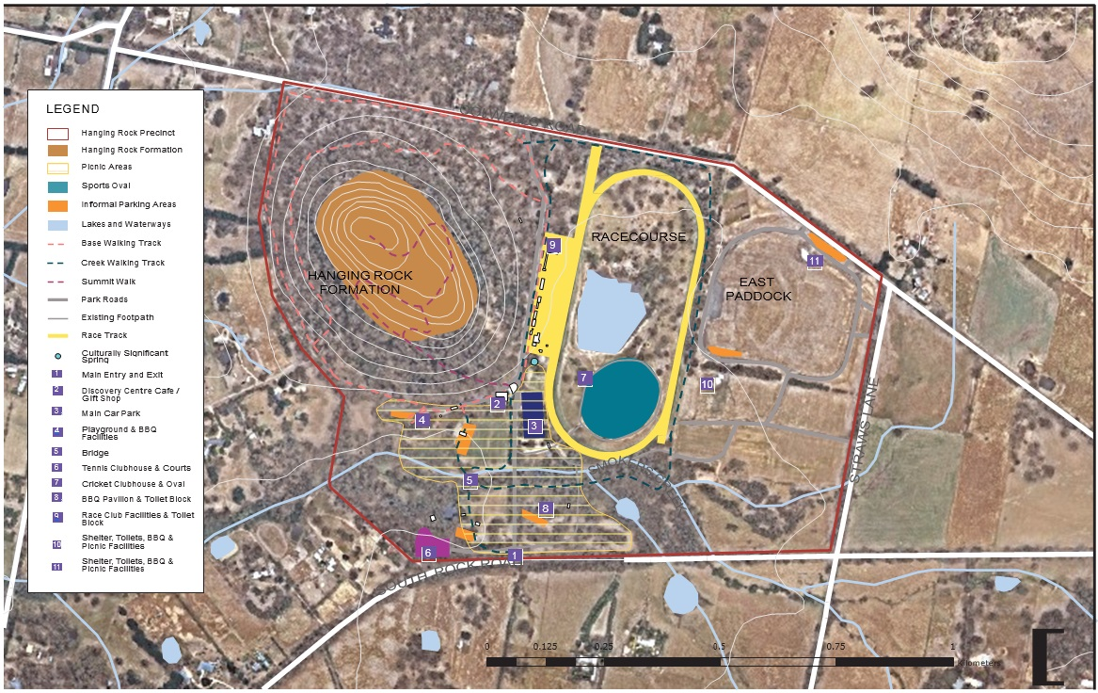

The variety of program of activities in Hanging Rock has contributed to its increase in popularity as a place to visit for local residents and tourists. Figure 1 shows a rapid rise in entrance fee revenues, linked to the increase in number of visitors to the site paying entrance fees over

the last five years. Current figures have doubled from ten years ago. This increase in revenue is forecasted to continue in the future.1

Meanwhile, Figure 2 shows a breakdown of attendance for the various events held at the site from 2006 onwards, including intermittent events and those which have not been continued. Additionally, this shows the range of the scale of events that are held onsite in terms of attendance numbers, showing that the site is capable of handling major and minor events.

200,000

180,000

160,000

140,000

120,000

100,000

80,000

60,000

40,000

20,000

Historical

Forecast

Figure 17. Attendance Figures at Hanging Rock. Source: SGS Economics & Planning (2018)

1 Revenue generated by entrance fees is directly linked to visitor numbers, which are forecast to grow in

*Hanging Rock Master Plan - Financial Planning*, SGS Economics and Planning, 2018).

Table 1. Paid Event Attendees Visitor Data at Hanging Rock 2007-2018. Source: Macedon Ranges Shire Council

|  |  |  |  |  |  |  |  |  |  |  |  |  |
| --- | --- | --- | --- | --- | --- | --- | --- | --- | --- | --- | --- | --- |
|  | 2006/07 | 2007/08 | 2008/09 | 2009/10 | 2010/11 | 2011/12 | 2012/13 | 2013/14 | 2014/15 | 2015/16 | 2016/17 | 2017/18 |
| Current Events |  | | | | | | | | | | | |

|  |  |  |  |  |  |  |  |  |  |  |  |  |
| --- | --- | --- | --- | --- | --- | --- | --- | --- | --- | --- | --- | --- |
| Craft Market (October & December) |  |  |  |  |  | 2590 | 6921 | 3160 | 2852 | 3072 | 3330 | 3148 |
| Frontier concerts |  |  |  |  | 15000 | 12500 | 34000 |  | 26706 | 17514 | 19644 | 19916 |
| New Years Day Races | 6474 | 3387 | 6314 | 4546 | 6345 | 4721 | 5011 | 3130 | 4321 | 3027 | 3673 | 3667 |
| Australia Day Races |  | 5606 |  | 4651 | 5330 |  | 4286 | 3745 | 3123 | 1970 | 3218 | 2801 |
| Car Rally | 9132 | 10433 | 7430 | 9616 | 11715 | 10451 | 12529 | 2300 | 7931 | 7411 | 3917 | 7957 |
| Film Night | 306 | 241 | 314 | 285 |  |  |  | 270 | 385 | 320 |  | 336 |
| Craft Market (March) |  |  |  |  | 4513 | 3698 | 1755 | 2715 | 2300 | 3072 | 1905 | 1470 |
| Camp Out at the Rock | 152 | 165 | 218 | 325 | 203 | 225 | 261 | 275 | 272 | 305 | 180 |  |
| Run the Rock |  |  |  | 1048 | 944 | 1708 | 1900 | 988 | 1308 | 1495 | 1612 |  |
| Obsolete/Intermittent Events |  |  |  |  |  |  |  |  |  |  |  |  |
| Carols at the Rock |  |  |  |  |  |  | 2000 |  |  |  |  |  |
| Harvest Picnic | 5560 | 5652 | 5444 | 4959 | 4418 | 4683 | 3605 |  |  |  |  |  |
| Warrior Dash |  |  |  |  |  |  | 2800 |  |  |  |  |  |
| Cult Dev Event - CoOpera |  |  |  | 192 |  |  |  |  |  |  |  |  |
| Little Athletics - X Country | 2500 |  |  |  |  |  |  |  |  |  |  |  |
| Total Events Attendance | 24124 | 25484 | 19720 | 25622 | 48468 | 40576 | 75068 | 16583 | 49198 | 38186 | 37479 | 39295 |

1. Walking trail at Hanging Rock

##### Walking

Walking is another significant activity undertaken at Hanging Rock. Walking to the summit of Hanging Rock is a common activity undertaken to experience the mamelon formation, as well as getting uninterrupted views once at the top of the surrounding regions.

Passive recreation combined with a picnic is a large reason why the site is such a popular destination for families, as these provide a unique, healthy, and low-cost experience for a day-trip from Melbourne. The existing tracks on-site are diverse and cater to a variety of capacity levels.

General visitations to Hanging Rock has doubled in the past 10 years, and is currently the biggest pressure on Hanging Rock.

Maintenance and Upgrades

Enhancing the trail networks will distribute the forecast ongoing influx of tourists who are predicted to visit the area, while providing opportunities to better maintain the surrounding sensitive environments. This will contribute to creating varied visitor experiences for different user groups. Enhancements to these trail networks will also improve safety and accessibility for users. All improvements need to be coordinated and managed to reflect the values of the site.

Future at Hanging Rock

Different and better defined walking trails could be provided to lessen the environmental impacts created by the existing and at times, undefined, walking trails. This would also provide a varied experience for the user

as well as disperse visitors throughout the precinct, allowing for larger visitor numbers in the case of an event or public holiday when Hanging Rock is particularly popular.

Walking trails and movement network across the Precinct need to be located and designed to respect and manage the cultural and geological sensitivities of the Rock.

Some of the walking trails on or around the site may be considered for reclassification as shared trails to include cyclists. To accommodate the influx of new users, bike parking and other facilities may need to be provided at certain locations. Potential connections with other nearby trails in the network could be investigated as a way to bring more visitors to Hanging Rock. A connection from Hanging Rock to Woodend

is desired by the local community. From there on, the Council is currently undertaking studies for a potential connection to Daylesford through a rail trail.

##### Picnics

Picnics are one of the most popular activities at Hanging Rock and have been an activity on the site since as early as the 1860s, with many locals and day-trippers still taking part in this activity today.

The Age annual Harvest Picnic was an organised picnic event that ran from approximately 1993 to 2013. At its peak it attracted around 12,000 people and was held on the lawns in front of the existing cafe/Discovery Centre. Inevitably this attracted many visitors to walk around and climb the rock itself.

Current picnic facilities include scattered picnic tables, barbeques, and associated toilet facilities and have proved to be well used by visitors to the Rock.

Maintenance and Upgrades

Picnic amenities have been incrementally upgraded to provide better and more varied picnic spots for visitors, including protection from different weather conditions. However, some areas/shelters will still require upgrades in the future. Upgrades are also required to improve aesthetics, quality and accessibility to these and potentially new picnic areas.

In the Region

The Macedon Ranges provides many open spaces (both regional and local level parks)with picnics and bbq facilities. Hanging Rock is one of the most popular picnic spots in regional Victoria, attracting many visitors every year for this purpose. The area is family friendly, and provides a passive activity that a range of people can enjoy.

Future at Hanging Rock

Picnics are an integral part of the Hanging Rock experience. Suggestions to enhance this social aspect at the rock could include:

* An annual “Picnic at Hanging Rock” day
* Provide pre-made picnics at the Cafe to take out to the picnic areas.

1. Picnics at Hanging Rock

##### Horse racing

The tradition of horse racing at the Rock extends for almost 160 years. It has always been an infrequent use – usually twice a year, and now on New Year’s Day and Australia Day. The events require substantial infrastructure and facilities, including a safe and well-maintained course, pavilion, toilets, access and parking facilities. The events are well-recognised on the country horse

racing calendar, and enjoyed by approximately 3000-4000 people per event, being drawn primarily from Victorian regional and metropolitan areas.

The Hanging Rock Racing Club (now known as the Kyneton and Hanging Rock Racing Club) was established in 1886 and they continue to organise and manage the race events. Country Racing Victoria is the umbrella organisation for racing events outside the Melbourne metropolitan area.

The Hanging Rock Races are one of several country race days on the Victorian calendar. The Hanging Rock races are particularly popular amongst race-goers for its aesthetic qualities and picnic facilities. There are also other country races in the general region held in nearby racing clubs.

In the Region

Within the region, country racing is a popular event and there are many other race venues with more frequent meets than at Hanging Rock. However, despite its limited number of meets, the races held at Hanging Rock are highly regarded because of the venue’s exceptionally picturesque setting, longevity of continuous use, and its other historical associations.

Future at Hanging Rock

The racecourse remains a highly valued recreational facility at Hanging Rock. With its continuous use, the following could be considered:

* Removal of permanent fencing to allow greater public use of the racecourse on non-race days
* Maintain current level of use of two races per year
* Upgrade of the Racing Club facilities to meet new regulations and retaining these in its current location



Above image: Country Race Venues near Hanging Rock

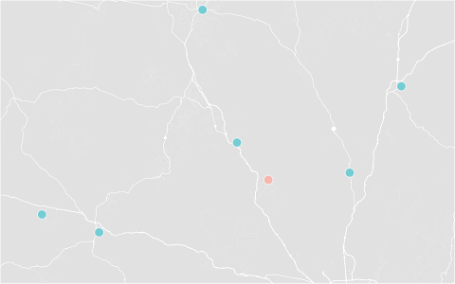

BENDIGO JOCKEY

CLUB

SEYMOUR

RACING CLUB

KYNETON

BET365 PARK

HANGING ROCK

RACING CLUB

KILMORE

RACING CLUB

BURRUMBEET PARK &

WINDMERE RACING

CLUB

BALLARAT

TURF CLUB

|  |  |  |  |
| --- | --- | --- | --- |
|  | Racing Club | Annual Race Meets | Km from Hanging Rock Racing Club |
| 1 | Hanging Rock Racing Club | 2 |  |
| 2 | Kyneton Racing Club | 12 | 22.5km |
| 3 | Kilmore Racing Club | 13 | 42.7km |
| 4 | Seymour Racing Club | 16 | 81.0km |
| 5 | Ballarat Turf Club | 27 | 85.7km |
| 6 | Burrumbeet Park & Windmere Racing Club | 1 | 107km |
| 7 | Bendigo Jockey Club | 22 | 92.1km |

1. Hanging Rock Racing Club Facilities
2. Race Track at Hanging Rock



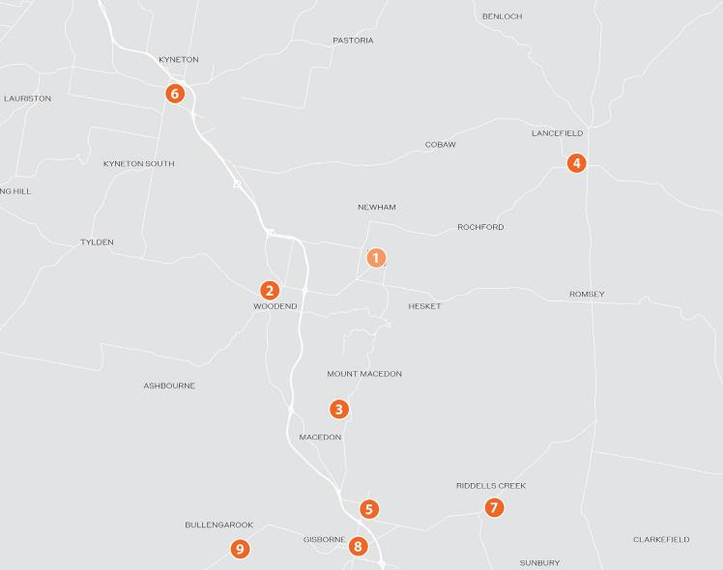

Above image: Tennis Clubs

##### Tennis

Four tennis courts are situated near the entrance to the reserve on South Rock Road. In reasonable condition, the tennis courts were constructed in 1991, however they require surface upgrades. Lighting for use at night is an option but this is not being considered at present.

|  |  |  |  |
| --- | --- | --- | --- |
|  | Tennis Club | No. of courts | Km from Hanging Rock Tennis Club |
| 1 | Hanging Rock Tennis Club | 4 |  |
| 2 | Woodend Tennis Club | 6 | 6.3km |
| 3 | Macedon Tennis Club | 8 | 9.4km |
| 4 | Lancefield Tennis Club | 4 | 13km |
| 5 | New Gisborne Tennis Club | 4 | 14.5km |
| 6 | Kyneton Tennis Club | 10 | 15.5km |
| 7 | Riddells Creek Tennis Club | 3 | 16km |
| 8 | Gisborne Tennis Club | 8 | 16.6km |
| 9 | Bullengarook Tennis Club | 2 | 18km |

The Tennis Club has 25 members and has been operating for 30 years. There has been a suggestion to amalgamate the club with other tennis clubs in the region.

Maintenance and Upgrades

The Tennis Club facilities and courts are run down and would require significant investment to upgrade.

In the Region

Within the Macedon Ranges Tennis Association, there are 19 Tennis Clubs, with 8 of these located close (within 6-18km) to the Hanging Rock Tennis Club.

Membership numbers are also greater in surrounding clubs, with Woodend Tennis Club having in excess of 270 members and Macedon Tennis Club having approximately 120 members.

Future at Hanging Rock

Due to the current facilities requiring investment to upgrade, options include:

* Retain the Tennis Club and upgrade the facilities, but without lighting for use at night; or
* Amalgamate the club with or share the courts at the existing club in Woodend,
* Remove the Hanging Rock courts/clubhouse and revegetate the land.

##### Petanque

The Woodend Hanging Rock Petanque Club (locally known as Petanque at the Rock) has one piste (gravel car park) with storage on site. It utilises an informal car parking area past the Discovery Centre and adjacent to the heritage listed hexagonal women’s toilet. The club usually plays during summer evenings.

The club has around 70 members and plays socially every Thursday evening. The club also holds a few events and tournaments every year.

Maintenance and Upgrades

The course currently utilises an informal car park. The site needs more shelter for different weather conditions and maintenance on the gravel piste.

In the Region

The only other Petanque Club in the region is the Mt Macedon Petanque Club in Gisborne, which has similar gravel pistes and facilities.

Future at Hanging Rock

As the course utilises an informal car parking area, this limits the times and days that the club can play. Lighting is not an issue as the club usually plays during summer evenings.

While the location is appropriate for now, if major works were to be undertaken, a relocation may be an alternative option. However, the club provides low-impact and informal recreation for both locals and visitors.

###### 

|  |  |  |  |
| --- | --- | --- | --- |
|  | Petanque Club | No. of courses | Km from Hanging Rock Petanque |
| 1 | Woodend Hanging Rock Petanque | 1 |  |
| 2 | Mt. Macedon Petanque Club | 1 | 16.5km |

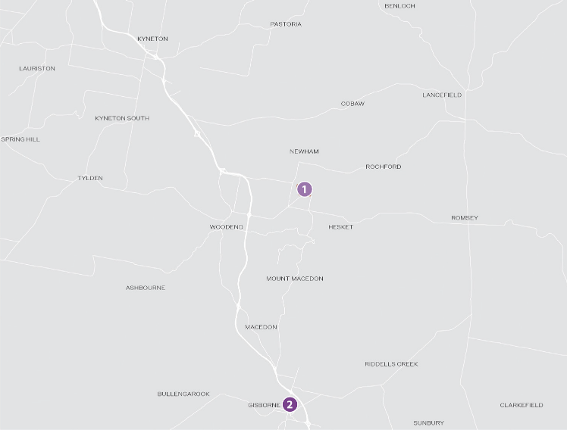

Above image: Petanque Clubs

###### 

|  |  |  |
| --- | --- | --- |
|  | Cricket Club | Km from Hanging Rock Cricket Club |
| 1 | Hanging Rock Cricket Club |  |
| 2 | Woodend Cricket Club | 6.5km |
| 3 | Macedon Cricket Club | 9.5km |
| 4 | Kyneton Cricket Club | 16.1km |
| 5 | Romsey Cricket Club | 16.2km |
| 6 | Gisborne Cricket Club | 17km |
| 7 | Malmsbury Cricket Club | 25.2km |

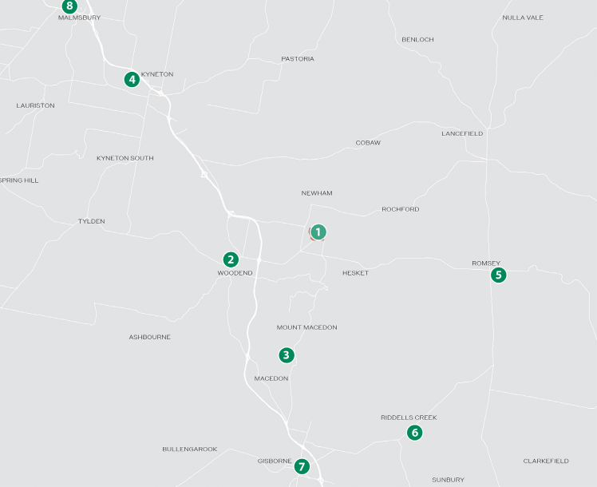

Above image: Cricket Clubs

##### Cricket

A cricket oval is situated inside the racetrack, with a clubhouse, and is utilised in the warmer months. The synthetic cricket pitch was recently renewed.

The Hanging Rock Cricket Club is an active club with at least one senior and three junior cricket teams.

Maintenance and Upgrades

The Cricket Club facilities require improvement in both building standards and quality. Currently, the cricket oval is not being irrigated.

In the Region

There are many other cricket clubs in the area, the largest being the Gisborne Dragons Cricket Club, which is over 150 years old. Hanging Rock Cricket Club, Gisborne Dragons Cricket Club and other local cricket clubs are all part of the Gisborne & District Cricket Association, which has a total 22 clubs within the wider region.

Future at Hanging Rock

The Cricket Oval would require upgrades such as improved irrigation and amenities upgrades to enhance the club’s activities. These upgrades

would make it possible to host exhibition matches, if ever an interest were to be expressed. However, this may have impacts on environmental and passive recreational values.

###### 

|  |  |  |  |  |  |
| --- | --- | --- | --- | --- | --- |
| Fishing Area (Order of distance from  Hanging Rock Dam) | | Area | Fishing Area (Order of distance from  Hanging Rock Dam) | | Area |
| 1 | Hanging Rock Dam | Woodend | 7 | Bolinda Creek | Bolinda |

* + 1. Fishing

|  |  |  |  |  |  |  |
| --- | --- | --- | --- | --- | --- | --- |
|  | 2 | Deep Creek | Lancefield | 8 | Jacksons Creek | Gisborne |
| 3 | Gisborne Creek | Macedon | 9 | Upper Coliban Resevoir | Kyneton South |
| 4 | Rosslyne Resevoir | New Gisborne | 10 | Tyldon Resevoir | Tyldon South |
| 5 | Campaspe River | Kyneton | 11 | Lauriston Resevoir | Kyneton |
| Fishing is a casual activity accessed by the platform on the dam inside the | 6 | Riddells Creek | Riddells Creek | 12 | Malmsbury Resevoir | Malmsbury |
| race track. Adults are required to obtain a fishing licence for this activity,  available for purchase at Woodend or Kyneton, but not from within the reserve. Main fish species in the dam include Trout and Redfin, stocked annually by the Victorian Fisheries Authority. The dam is seen as a family- friendly fishing location for locals and visitors. |  | | | | | |
| Maintenance and Upgrades |
| There are few facilities required for the fishing area near the dam at Hanging Rock. Currently there are a few picnic tables and benches located adjacent to the dam, as well as a small jetty. |
| In the Region |
| There are other areas for fishing in the region, however many are from the Campaspe River or surrounding reservoirs. |
| Future at Hanging Rock |
| Fishing at Hanging Rock provides a small family-friendly fishing location. Restocking would need to continue to allow for families to continue fishing in the dam. |
| Fishing in this location is a casual activity and it is not considered to have a major impact on the overall values of Hanging Rock. |

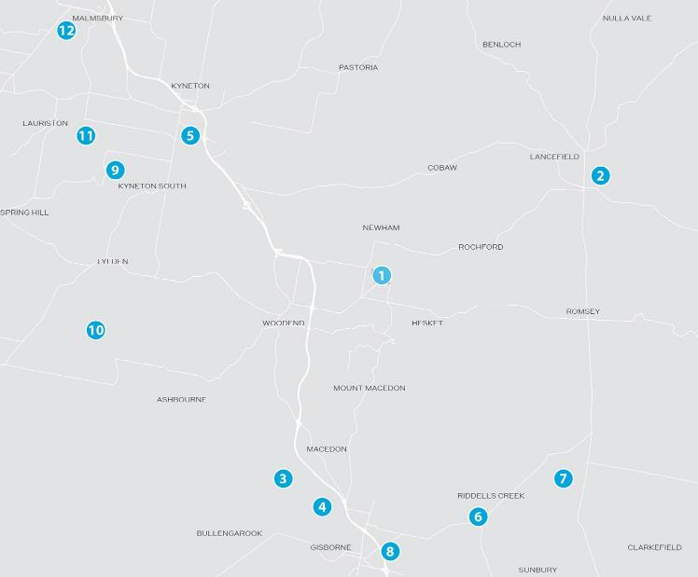

Above image: Fishing Areas

##### Concerts

Frontier Touring has coordinated and managed nine concerts at the Rock, since 2010, with an average of one per year1. The concerts are held on

the East Paddock and offer views of Hanging Rock as a backdrop to the music stage. There are up to two major events per year, hosting a suite of past folk and rock legends. The Council support this event being held only onec or twice per year. The limited frequency of these concerts add to their iconic status.

Concerts are accessed by shuttle buses to and from Woodend and private buses from further afield. These options have greatly reduced the need for car parking during concert events. Apart from the main car park, temporary event parking is also provided within the East Paddock, the Cricket Oval and the two ovals, but is not permitted on the surrounding roads. Carpool visitors are able to park in the reserve for free.

These events have been managed through a five-year agreement with the Macedon Ranges Shire Council and are therefore not necessarily a confirmed long-term event. The concerts have significantly raised the profile of Hanging Rock, and created a unique destination for music events. They also add significant economic benefit to the region as a result of accommodation and servicing requirements. There are very few complaints, if any, from local residents about generated traffic and noise. However, the concert events may have impacts on wildlife in the

reserve. In addition, it is recognised that the East Paddock has particular Aboriginal cultural significance and this needs to be further considered as part of ongoing management processes.

Maintenance and Upgrades

Suitable car parking should be provided dependent on the expected size of the event, as well as traffic management for surrounding areas. Parking and further development associated with the concerts should avoid the high point in the East Paddock.

Hosting larger or more frequent concerts would also imply the need to upgrade facilities and amenities in order to comfortably allow for large crowds at Hanging Rock. Recent shelter upgrades have focused

on providing support for general visitations and small events as it is not feasible to upgrade or provide permanent facilities for only a few events. Increased frequency or size of events would place significant pressure on infrastructure and the environment around the Rock.

Future at Hanging Rock

Concerts at Hanging Rock have significantly contributed to the increased profile of the site over the last few years. Ensuring concerts are culturally appropriate to the Aboriginal Traditional Owners will be a consideration regardless of other changes.

Considerations for the future of concerts could include:

* Reduce or cease further concerts on the site.
* Maintain existing level of concerts on the site.
* Smaller scale concerts

1 Nine concerts over eight summers, with two years featuring two concerts and one year featuring no concert owing to a cancellation.

**48** Concerts at Hanging Rock (source: Visit Macedon Ranges)

##### Other events

Other events and activities at the Hanging Rock reserve, include:

* Classic Car Show
* Camp Out at the Rock
* Film Night
* Run the Rock – a 5km community fun run
* The Age Harvest Picnic (now discontinued)
* Summer markets held on the picnic grounds
* Evening tours of the Rock itself, guided by a park ranger

Future at Hanging Rock

Most of these events rely solely on the Precinct’s public amenities, open picnic grounds and car parking. It is considered that one-off type activities, such as those listed, do not have a significant impact on the environmental values of Hanging Rock.

Annual events will continue to require car parking and traffic management and ‘clean up’ efforts to ensure that the Precinct is maintained and left in good condition after an event. In addition, events will need to be well planned with clear guidelines given to ensure the appropriate use and protection of sensitive areas, including consultation with Aboriginal Traditional Owners to ensure events are culturally appropriate and include support for Aboriginal Traditional Owner involvement.

**49** Run the Rock fun run

1. Classic Car Show at Hanging Rock (Picnic at Hanging Rock, Feb 2018)

1.2 Potential future

Maintaining the current management and governance of the Precinct indicates that the possible trajectory for the activities could be:

Concerts and events

* Continued events on the East Paddock, with regular review of the number and type of concerts via agreements with Council and consultation with Aboriginal Traditional Owners. While at present there is no indication that the number or frequency of events is expected to increase there is the potential for the current usage to provide a precedent for demands by current or other operators.

There is also a potential that all events may cease due to the inability of current facilities to cater for additional numbers or frequency of events.

* Continued occasional conflicts with car parking and traffic management of surrounding road network.
* Degradation of picnic grounds and East Paddock should event frequency increase. This is currently managed through limiting annual events and numbers, along with requirement for an event

management plan that requires clean-up and rehabilitation if required.

Sports clubs and facilities

* Continued use of local sporting facilities would see a need for regular upgrading of facilities and parking areas. The cricket ground, race track and tennis club all require facility upgrades to operate in the long term.
* Horse racing to remain at current levels. However there is the ongoing pressure to upgrade facilities based on new regulations and expectations for modern amenities.
* Membership numbers of most sporting clubs may not increase, indicated by stagnant numbers in recent years. Potential demand for expansion of clubs and facilities if member numbers do increase.

Walking trails and picnic grounds

* Increased visitor numbers (especially in the short term).
* Continued degradation of parts of the Rock and vegetated areas from undefined paths and ongoing human interruption.
* Potential reduction in wildlife interactions due to increase in visitation and ongoing use of sports clubs.
* Ongoing need for upgrades to picnic grounds, park infrastructure and public amenities with increased usage.

1. Racecourse Road

Environment, Land,Water and Planning

